ANNUAL REPORT
VISHAKA COMMITTEE

Committee Members:
- Dr. Ritu Madhan – Convenor
- Ms. Payal Maheshwari – Member
- Ms. Vibhuti Khedekar – Member
- Ms. Cheryl Machado – Member
- Mr. Vijay Almeida – Member
As per the guidelines of the Vishka Committee, names of the committee members with their contact details (Email ID and Mobile Numbers) were prominently displayed in all classrooms, Common Room, and on Notice Boards near the lift and on every floor.
Dr. Ritu Madhan updated the entry level students of the role of the committee and means to approach the committee members in case of any grievances during the respective orientation sessions.
The committee jointly organized Vicchar Dhara, an idea generation competition for the prevention of sexual abuse in collaboration with the Women’s Development Cell under the aegis of the IQAC of the College. Eleven entries were received from the students and were scrutinized by three jury members and the prizes were announced. The prize winners are as follows:
- 1st Prize: Ms. Zikra Syed Joseph Babu
- 2nd Prize: Ms. Mishri Modi
- 3rd Prize: Ms. Aditi Anand Mogaveera
Dr. Ritu Madhan and Ms. Jacquiline Colaco (Women’s Development Cell) jointly organized and conducted the activity. Certificates were presented to the prize winning students and the participants of the competition.
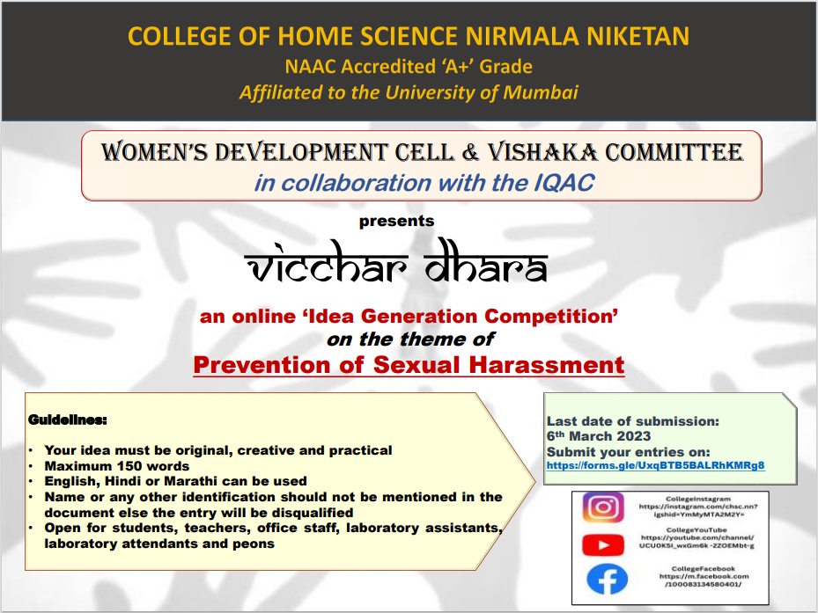
Vishaka Committee also jointly organized a movie screening, “Provoked” on the theme of Sexual abuse in collaboration with the Women’s Development Cell on 8th March 2023. Thirty eight students attended the movie screening, after which key concepts of abuse were discussed with the students. Ms. Payal Maheshwari and Ms. Vibhuti Khedekar jointly organized and conducted the activity.
.
No cases of sexual abuse have been reported in the academic year 2022 – 23.

Dr. Ritu Madhan
PO, Vishaka Committee

