MOOC REPORT
2022 – 23

Members of the Committee:
- Dr. Ritu Madhan – Convenor
- Ms. Rhonda Divecha
- Ms. Fatima Kader
The academic year started with a series of orientations for the students at all levels; F.Y.B.Sc, S.Y.B.Sc, T.Y.B.Sc and M.Sc I. A separate orientation was planned for the students of M.Sc II of all the branches on 23rd July 2022, where all the doubts and concerns of the students were clarified.
Fifty six students enrolled for various courses during the academic year of which forty students successfully completed the course. Five students from the college topped the courses they had enrolled for.
Name of the Student | Class | Department | Topped the Course in
Vidula Vinay Karhadkar | M.Sc II | Foods, Nutrition & Dietetics | Product and Brand Management
Merlyn Dennis Mascarenhas | M.Sc II | Food Processing & Preservation | Dairy and Food Process and Products Technology
Ayesha Khan | M.Sc II | Foods, Nutrition & Dietetics | Basics of health promotion and education intervention
Asna Armar | M.Sc II | Food Processing & Preservation | Design, Technology and Innovation
Zainab Kagalwala | M.Sc II | Food Processing & Preservation | Product and Brand Management
A flyer of the MOOC Courses was displayed in every classroom along with a separate WhatsApp group to facilitate smooth conduct of courses for the students who had enrolled for the same.
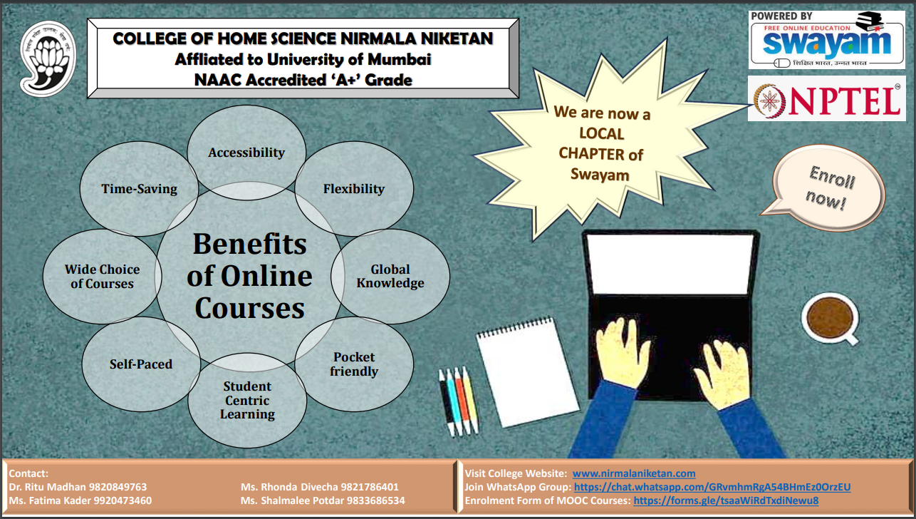 | 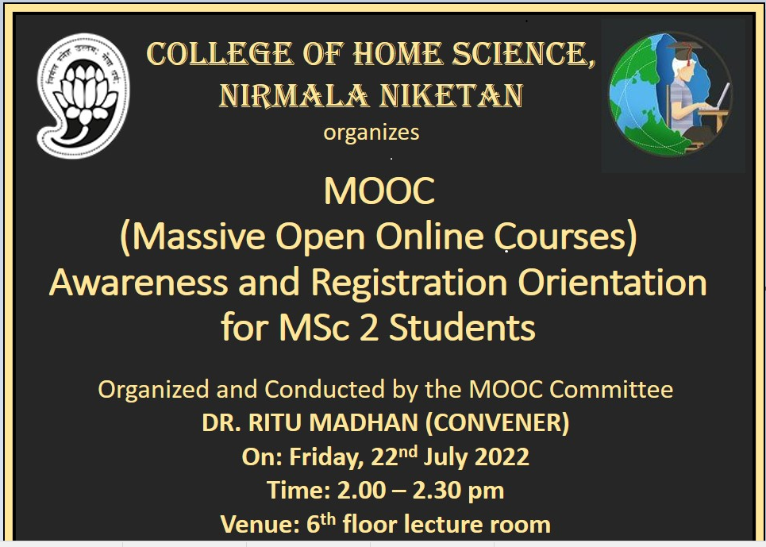

Reported by:
Dr. Ritu Madhan, Convenor

