REPORT ON ADD-ON ONLINE AND OFFLINE DIPLOMA COURSE IN
PERSONAL STYLING GROOMING AND FITNESS
2022 – 23
The Department of Textile and Fashion Technology conducted an Add-On Online and Offline Diploma Course in Personal Styling Grooming and Fitness affiliated to the University of Mumbai. The course has been coordinated by Dr. P. Goyal and Mrs. Vibhuti Khedekar in the academic year 2022 – 23. 21 students registered for the course from F.Y.B.Sc, S.Y.B.Sc and T.Y.B.Sc. The course commenced in the second week of February 2023 and 40.5 hours of classes were conducted till 7th April 2023. The course was conducted in online and offline mode and the course content (study material, notes, PPTs) were shared with the students through Google drive. The sessions were conducted by:
Shaifali Singh | Module I - Image Projection
Rianna Gorawal | Module II - Body Types for Different Personalities
Shveta Wadhavkar | Module III – Make-Up and Personal Shopping
Gaurav Kumar | Module IV- Fitness – Creative yoga
Debarati Roy | Introduction of the Course

The students submitted an assignment for every subject which was marked by the respective faculty out of 40 marks. The final exams carried a weightage of 60 marks. The final exams were held from 29th April and 1st May 2023. All the students performed well during the presentations and exams and were successful. The toppers of the course are:
- Overall Toppers- Ms. Sani Lopes (F.Y.BSc) and Ms. Rahila Khatri (T.Y.B.Sc)
- Best project work- Ms. Zenia Miranda (F.Y.BSc), Ms. Sanvi Rawool (F.Y.BSc) and Miss. Shreya Mistry (T.Y.BSc)
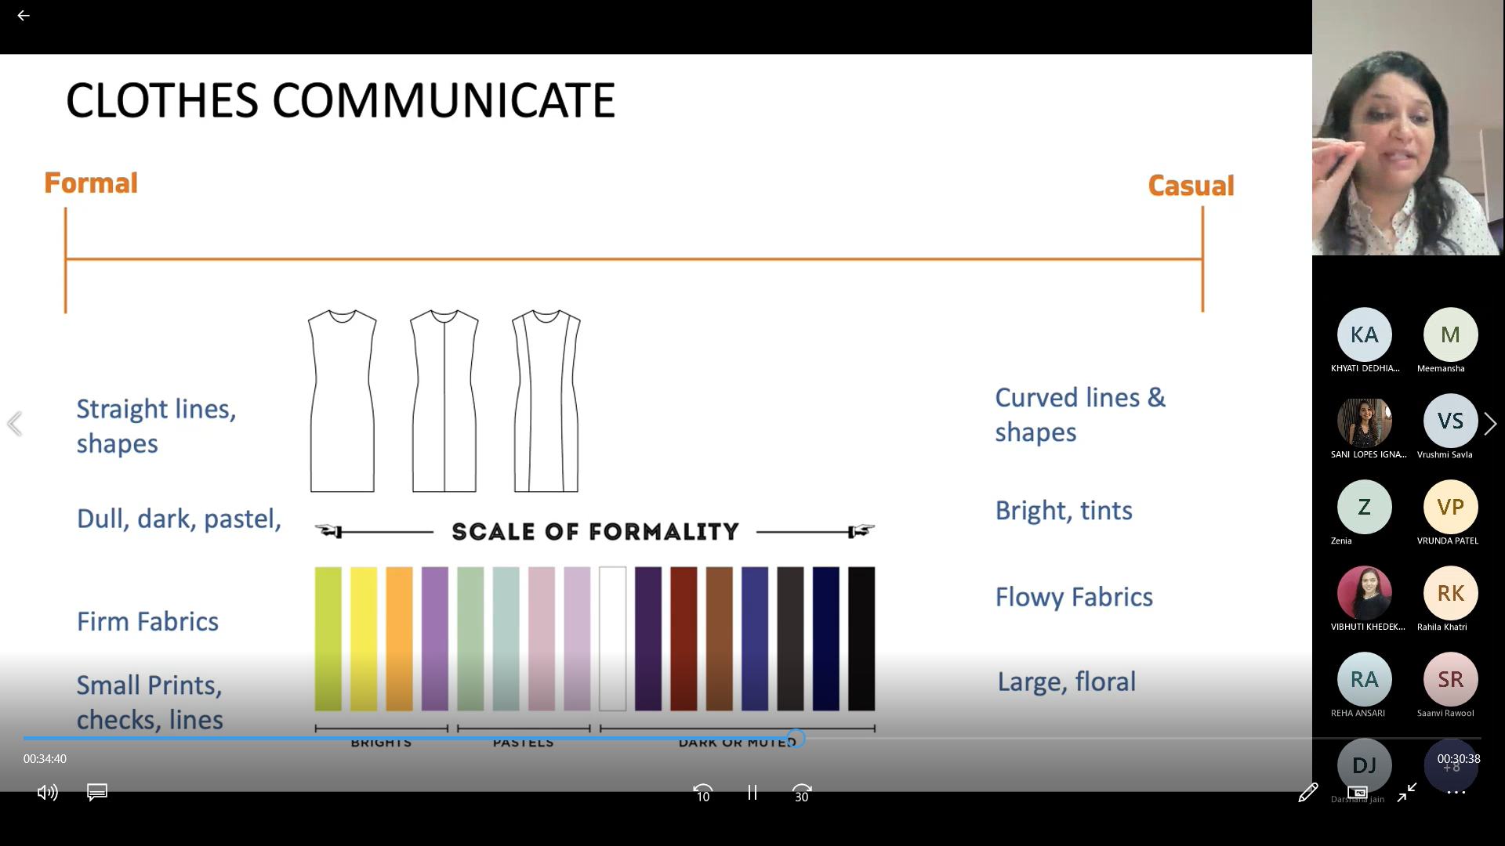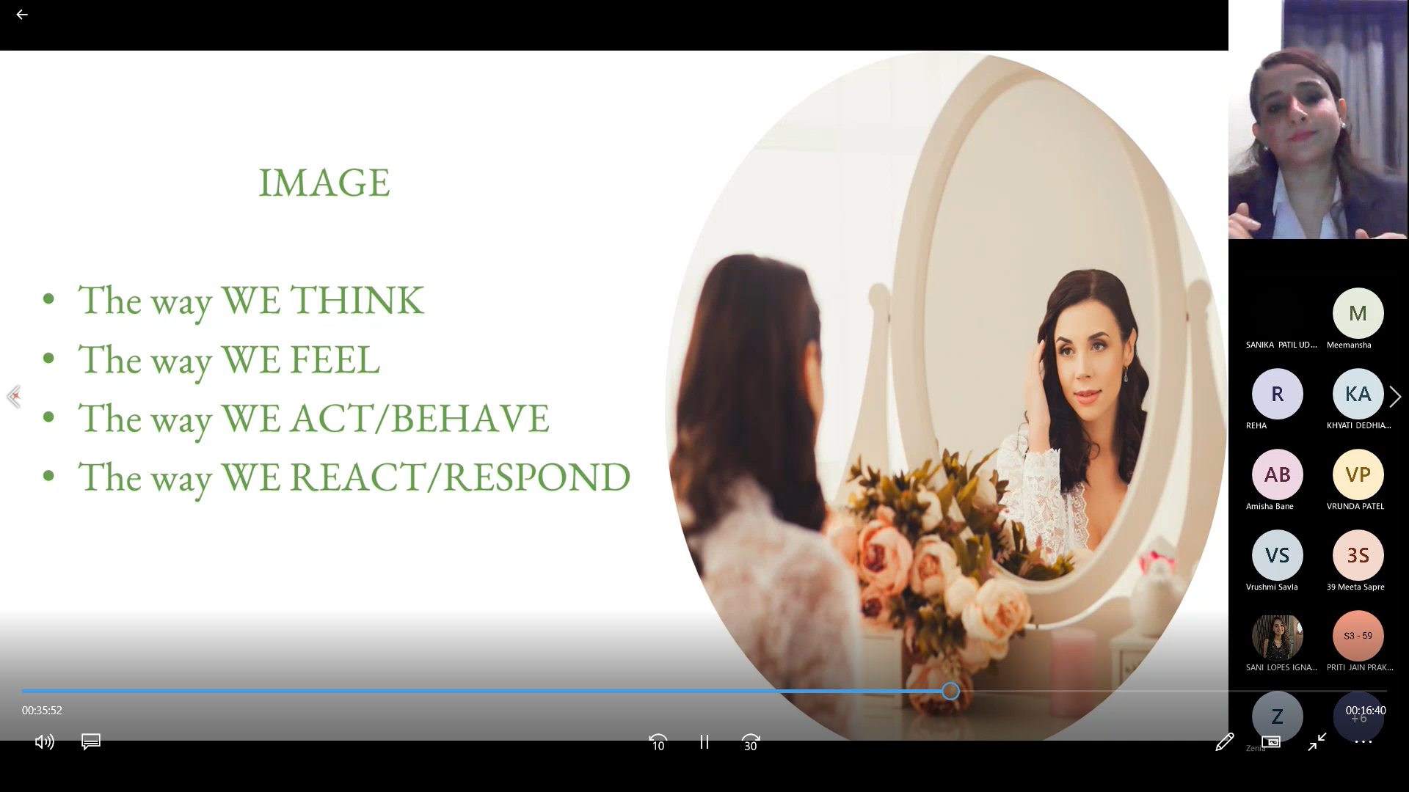
Online Sessions Conducted by Online Sessions Conducted
Ms. Shaifali Singh Ms. Shveta Wadhavkar

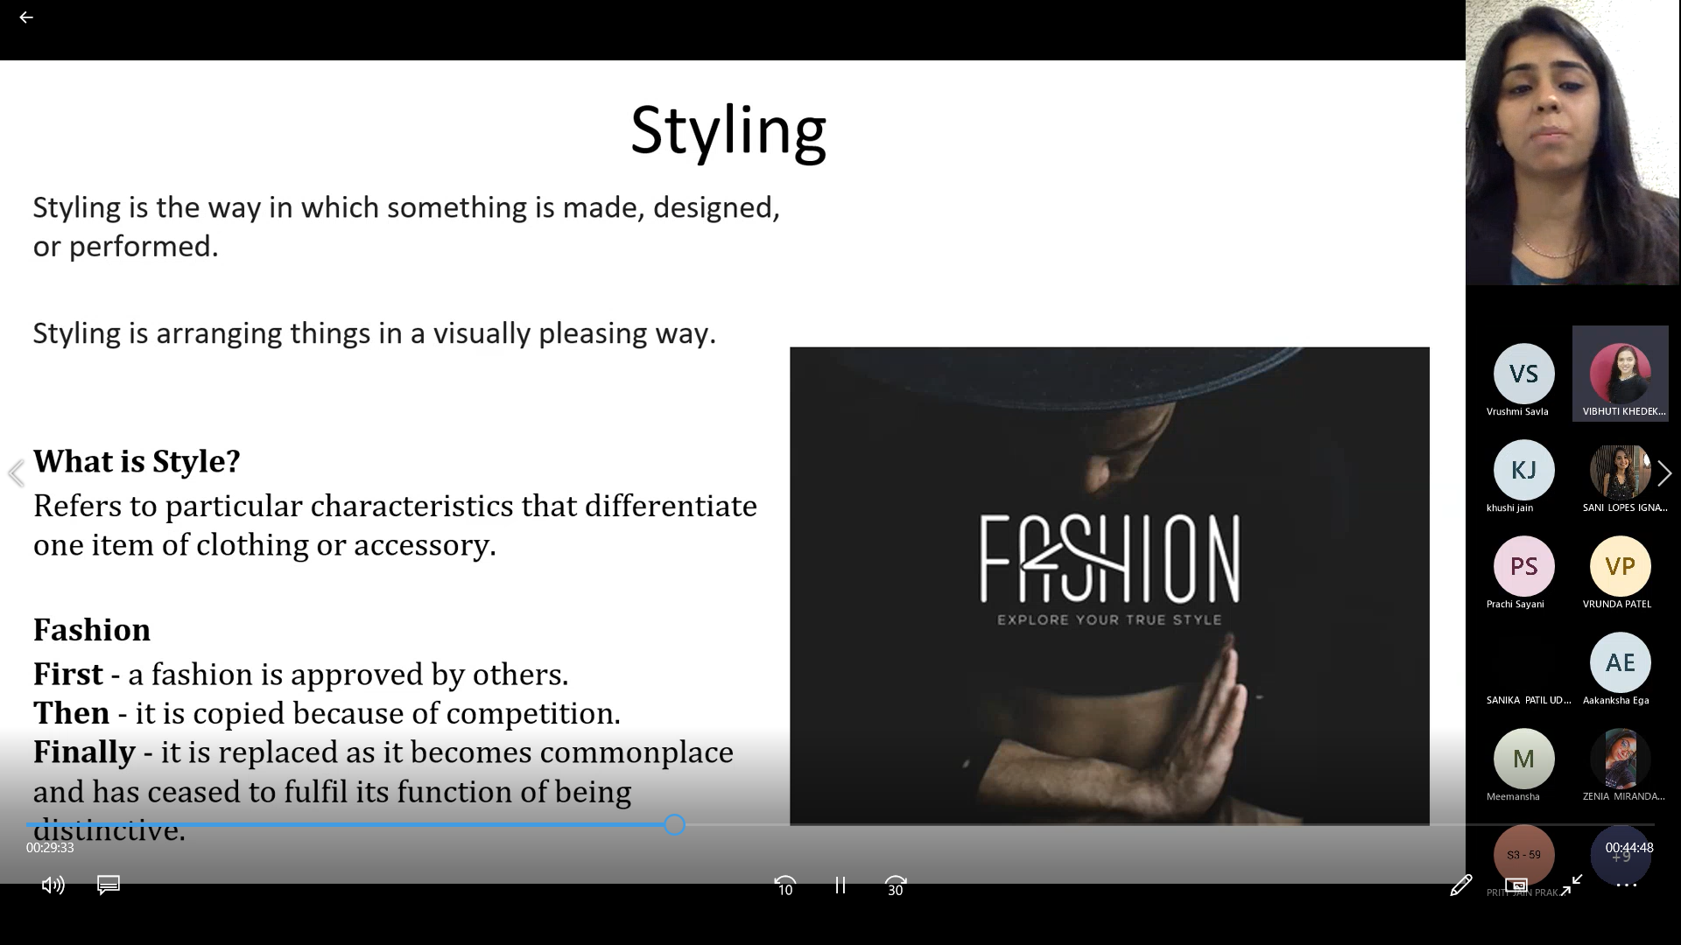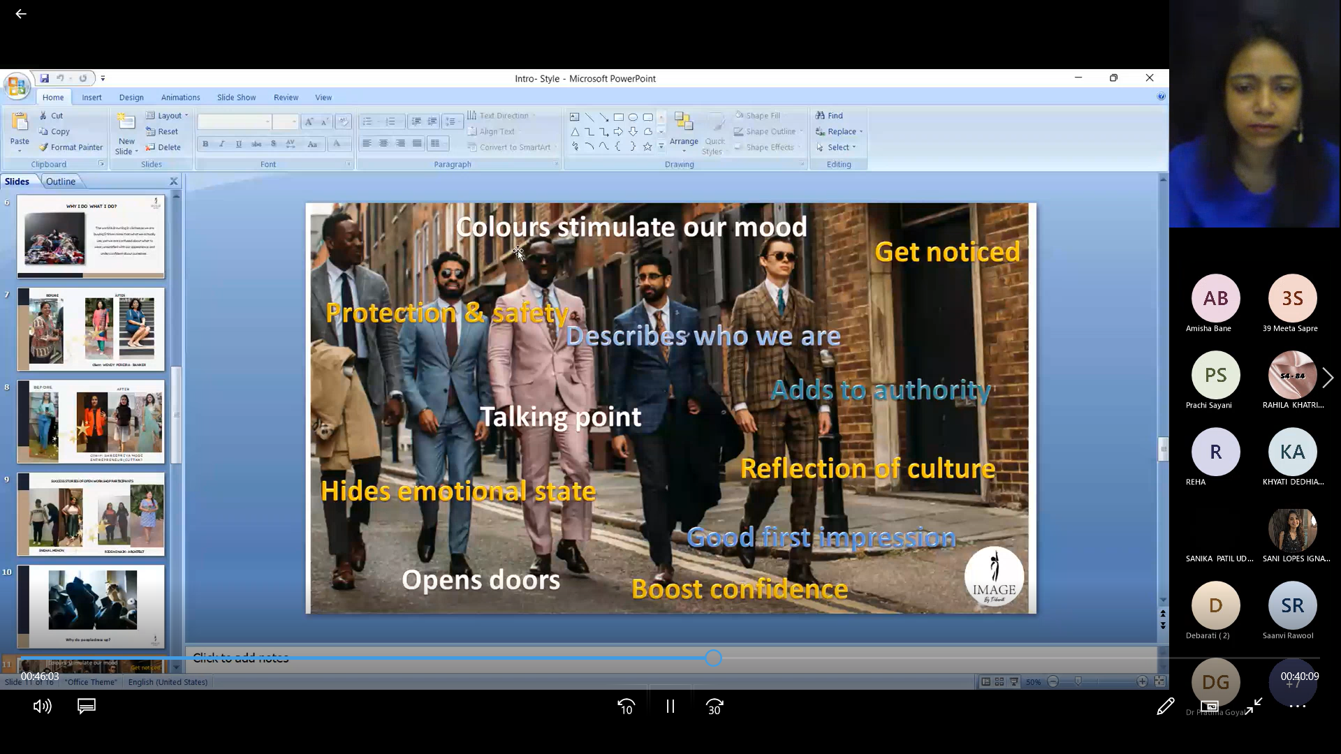
Online Sessions Conducted by Online Sessions Conducted
Ms. Rianna Gorawal Ms. Debarati Roy
Offline Sessions on Creative Yoga by Offline Sessions on Styling
Mr. Gaurav Kumar
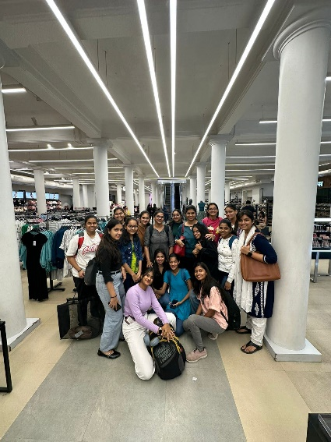
Offline Sessions on Offline Sessions on Personal Shopping experience
Body Types Makeup and Grooming at Zara and Westside

Vibhuti Khedekar
Course Coordinator

