REPORT ON MARATHI BHASHA DIVAS COMMITTEE ACTIVITIES HELD IN 2022-2023
Of all the contemporary Indo-Aryan languages, Marathi has some of the oldest literature. In India, it is one of the most widely used languages hence to honour the Marathi language and literature staff and students of the College of Home Science Nirmala Niketan conduct various activities.
PARTICIPATION OF STUDENTS IN THE “CHHATRAPATI SHAHU MAHARAJA- ESSAY COMPETITION ON THE TOPIC SAMAJKRANTIKARAK RAJASHRI SHAHU MAHARAJ
11 students participated in the essay writing competition organized by Chhatrapati Shahu Maharaj Research, Training and Human Development Institute (SARTHI), Pune on 14th October 2022.
LIST OF STUDENTS PARTICIPATING
SR NO | NAME | CLASS
1 | Sanika Uday Patil | TYBSC
2 | Shivani Salikram Gupta | FYBSC
3 | Aamina Irfan Glasswala | FYBSC
4 | Vaishnavi Yashwant Kanekar | FYBSC
5 | Ayushi Badela | FYBSC
6 | Sanskuti Chandrakant Ombale | FYBSC
7 | Shravani Mahendra Jadhav | FYBSC
8 | Aakansha Ega | FYBSC
9 | Nupur Chandrashekar Chavan | FYBSC
10 | Swizel Dilip Bagaji | FYBSC
11 | Aditi Anant Adsul | FYBSC

MARATHI BHASHA SAVRDHAN PANDHARWADA
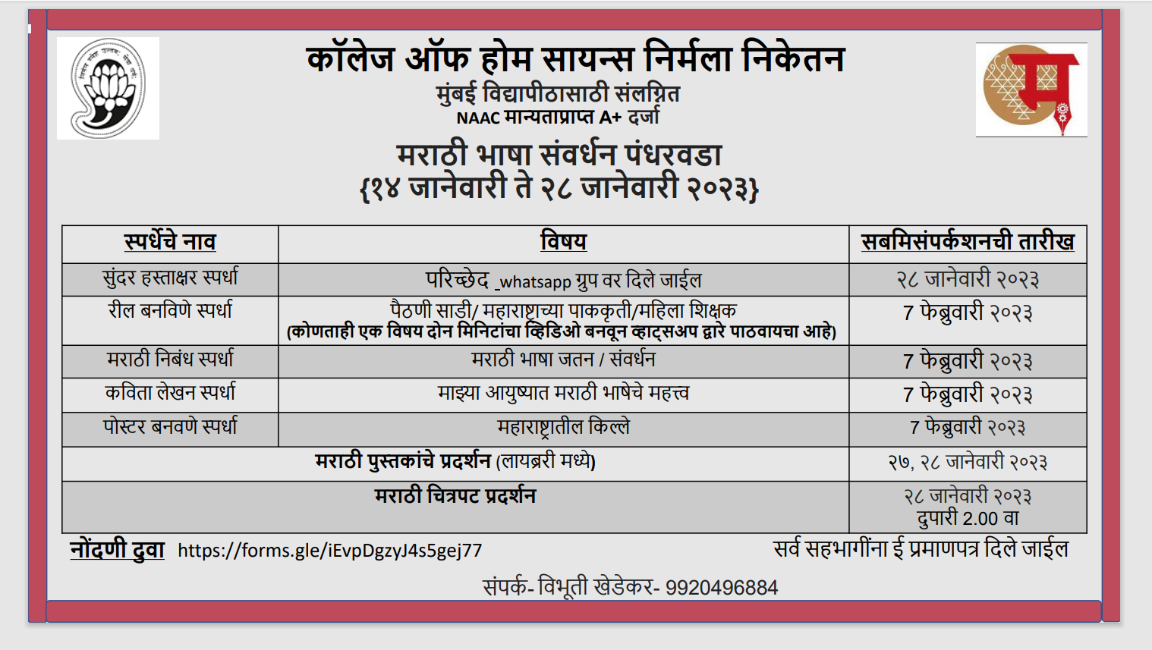
Marathi Bhasha Sanvrdhan Pandharwada” is celebrated from 1 to 15 January every year to preserve the glory of the Marathi language and for the conservation of the Marathi language all over Maharashtra.
The College of Home Science Nirmala Niketan organized various events and competitions both in online and offline mode to commemorate and celebrate the Marathi Language. Students from both Maharashtrian and non-Maharashtrian cultures enthusiastically participated in the same.
The details of the events and competitions are as follows: -
स्पर्धेचे नाव | विषय | सबमिसंपर्कशनची तारीख | एकूण विद्यार्थ्यांनी सहभाग घेतला
सुंदर हस्ताक्षर स्पर्धा | परिच्छेद whatsapp ग्रुप वर दिले जाईल | २८ जानेवारी २०२३ | 13
रील बनविणे स्पर्धा | पैठणी साडी/ महाराष्ट्राच्या पाककृती/महिला शिक्षक  (कोणताही एक विषय दोन मिनिटांचा व्हिडिओ बनवून व्हाट्सअप द्वारे पाठवायचा आहे) | 7 फेब्रुवारी २०२३ | 02
मराठी निबंध स्पर्धा | मराठी भाषा जतन / संवर्धन | 7 फेब्रुवारी २०२३ | 01
कविता लेखन स्पर्धा | माझ्या आयुष्यात मराठी भाषेचे महत्त्व | 7 फेब्रुवारी २०२३ | 00
पोस्टर बनवणे स्पर्धा | महाराष्ट्रातील किल्ले | 7 फेब्रुवारी २०२३ | 01
 | मराठी पुस्तकांचे प्रदर्शन (लायब्ररी मध्ये) | २७, २८ जानेवारी २०२३ | --
 | मराठी चित्रपट प्रदर्शन | २८ जानेवारी २०२३  दुपारी 2.00 वा | 30

The details of the winners are as follows: -
Winners of Hand Writing Competition
सुंदर हस्ताक्षर स्पर्धा

SR NO | NAME OF THE STUDENT | CLASS OF THE STUDENT | DETAILS OF THE PRIZE WON
1 | Ms. Vaishnavi Kanekar | F.Y.BSc | First Prize
2 | Ms. Nafisa Soni | S.Y.BSc | Second Prize
3 | Ms. Kirti Pevekar | S.Y.BSc | Second Prize
4 | Ms. Khushi Nimani | S.Y.BSc | Third Prize
5 | Ms. Tanvi Chavan | S.Y.BSc | Third Prize
6 | Ms. Sonali Modak | S.Y.BSc | Consolation
Winner of Reel Making Competition
रील बनविणे स्पर्धा
 | Ms. Sakshi Zinjad | S.Y.BSc | First Prize
Winner of Essay Writing Competition
मराठी निबंध स्पर्धा
 | Ms. Mansi Palande | T.Y.BSc Human Development | First Prize
Winner of Poster Making Competition
पोस्टर बनवणे स्पर्धा
 | Mr. Atharva Sanas | F.Y.GDVC | First Prize

Winners of Hand Writing Competition
सुंदर हस्ताक्षर स्पर्धा
First Prize
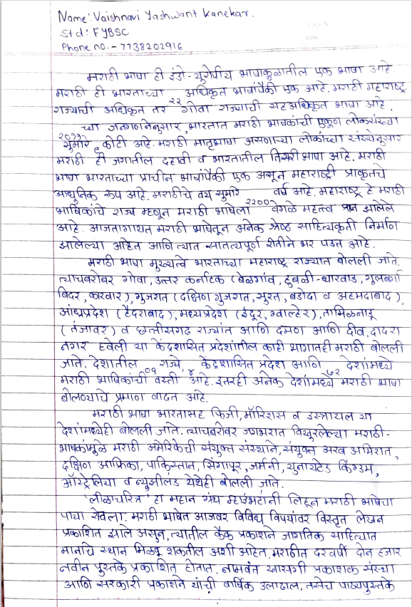
Ms. Vaishnavi Kanekar- F.Y.BSc
Second Prize
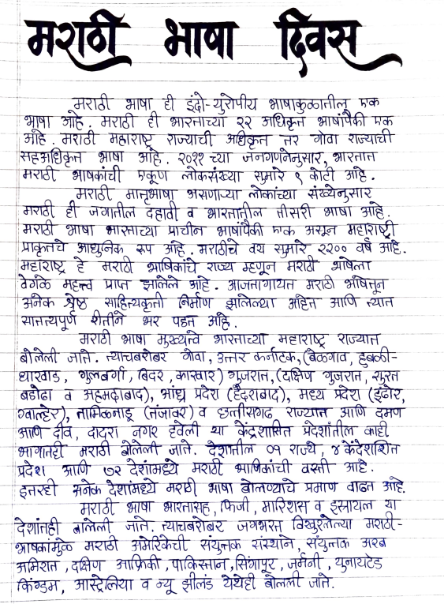 |  | 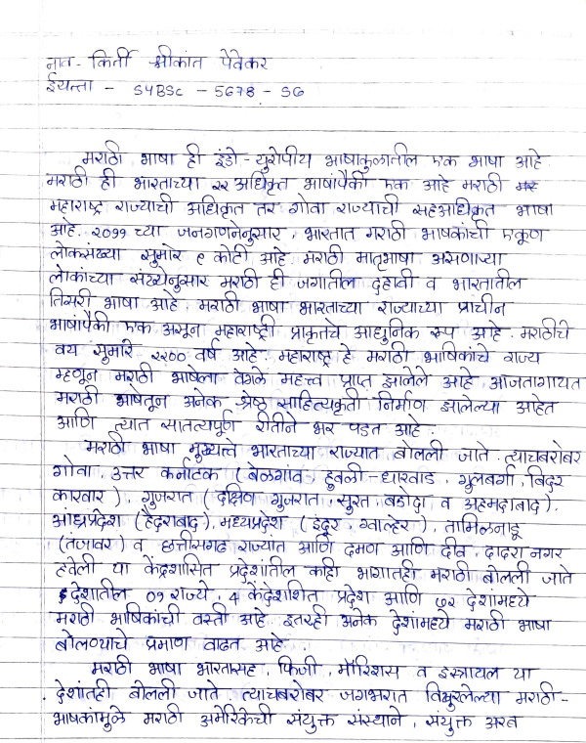
Ms. Nafisa Soni- S.Y.BSc |  | Ms. Kirti Pevekar S.Y.BSc
Third Prize
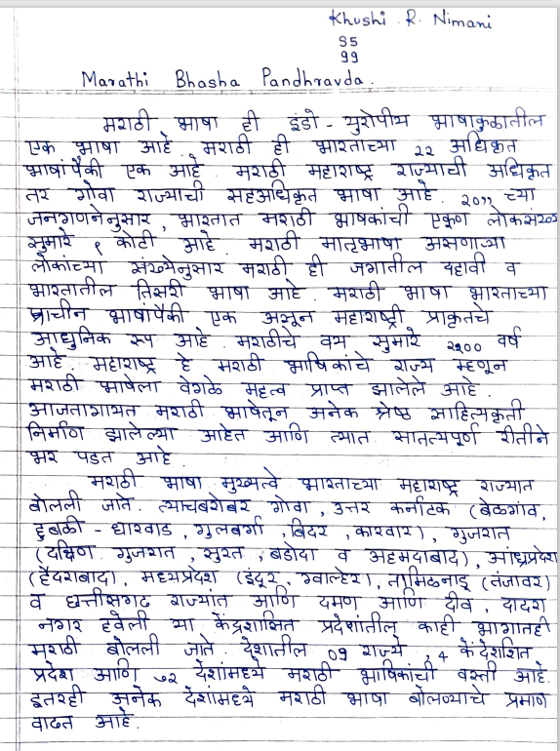 |  | 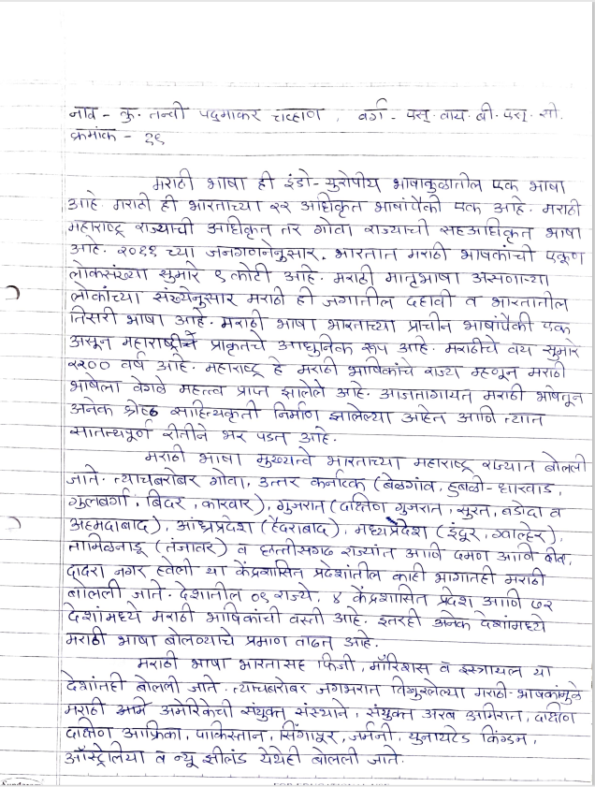
Ms. Khushi Nimani- S.Y.BSc |  | Ms. Tanvi Chavan- S.Y.BSc
Consolation Prize
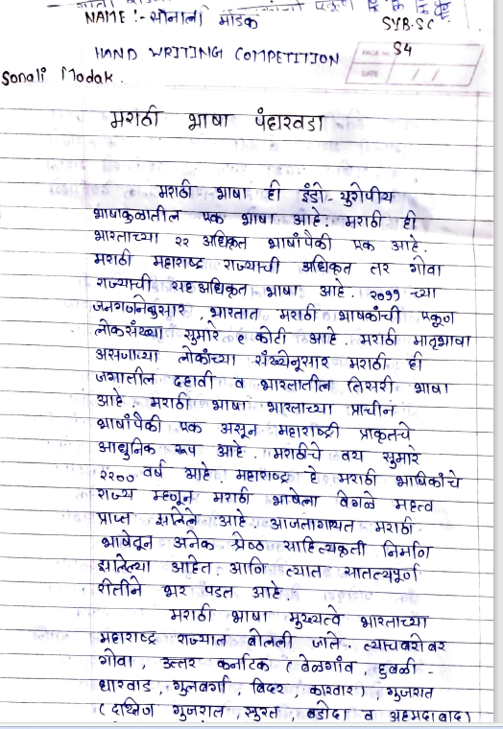
Ms. Sonali Modak- S.Y.BSc

Winner of Reel Making Competition
रील बनविणे स्पर्धा
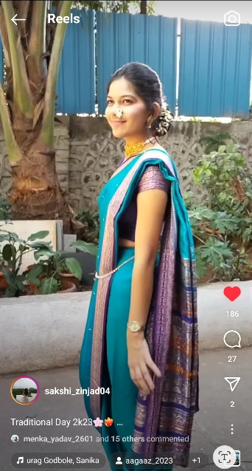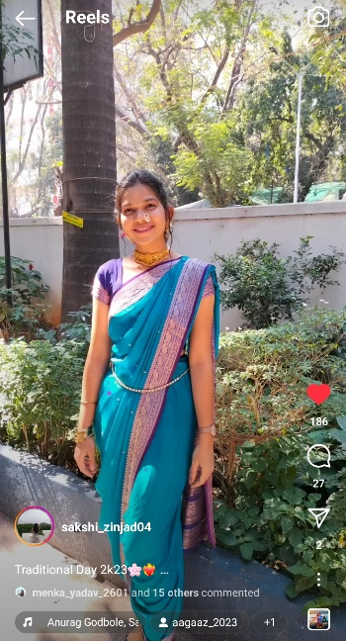
Ms. Sakshi Zinjad- S.Y.BSc

Winner of Essay Writing Competition
मराठी निबंध स्पर्धा
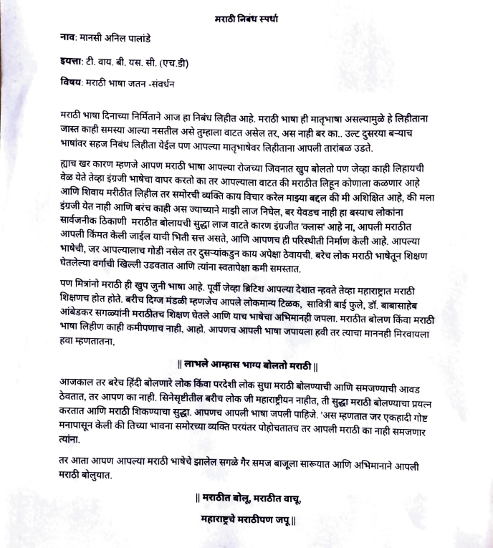
Ms. Mansi Palande- T.Y.BSc Human Development

Winner of Poster Making Competition
पोस्टर बनवणे स्पर्धा
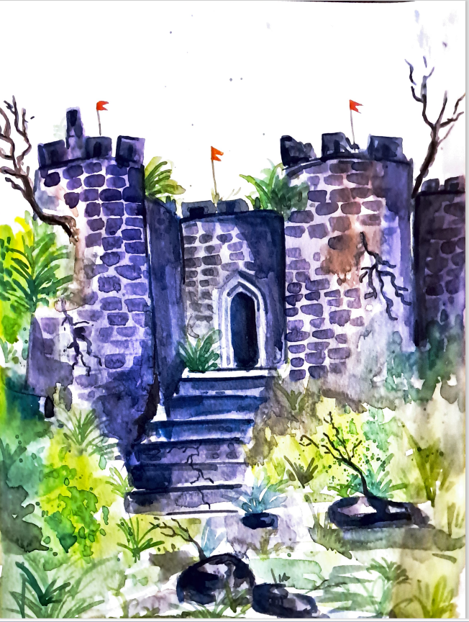
Mr. Atharva Sanas- F.Y.GDVC

मराठी पुस्तकांचे प्रदर्शन (लायब्ररी मध्ये)
EXHIBITION OF MARATHI LITERATURE BOOKS DISPLAYED IN THE LIBRARY
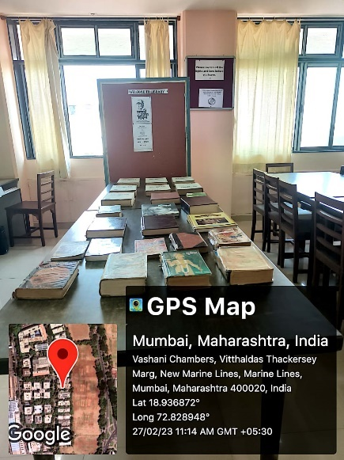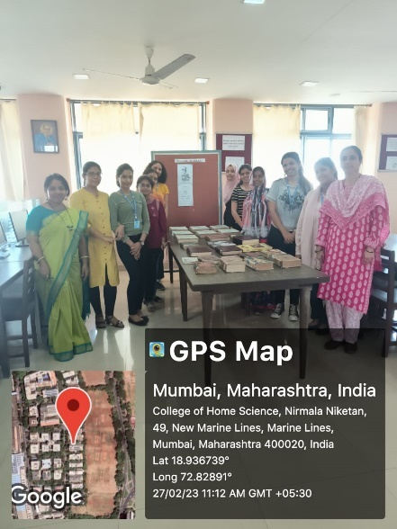
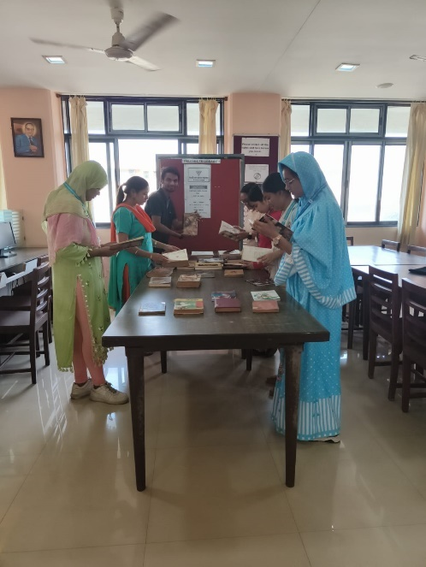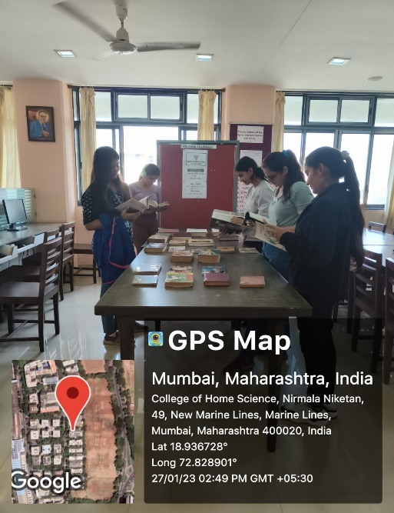

मराठी चित्रपट प्रदर्शन- दहावी फ
SCREENING OF NATIONALLY AND INTERNATIONALLY APPRECITED AND FOMOUS MOVIE- DAHAVI PHA
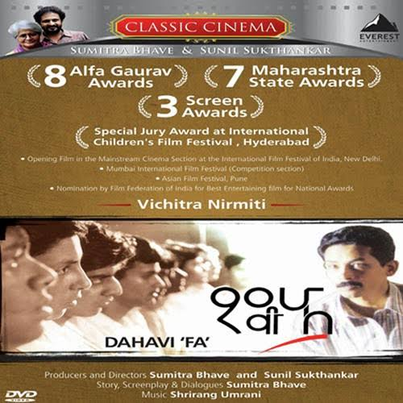
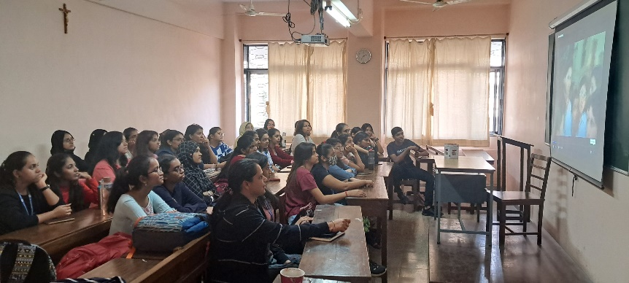
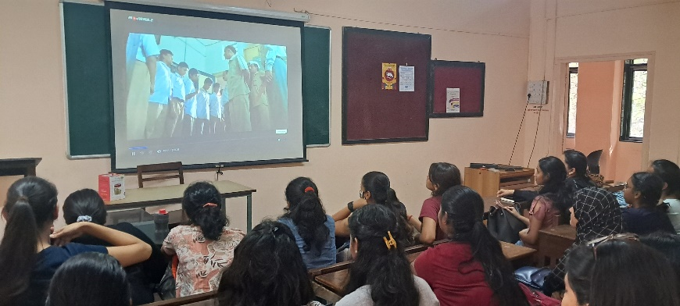
A total of 40 students watched the movie named Dahavai Pha

MARATHI BHASHA DIVAS CELEBRATION
Organized By: Marathi Bhasha Divas Committee, College of Home Science Nirmala Niketan
Marathi Bhasha Divas, or Marathi Language Day, is held on February 27 to commemorate the birthday of renowned Marathi poet Vishnu Vaman Shirwadkar, often known as “Kusumagraj.” Shirwadkar was a celebrated Marathi playwright, novelist, short story writer, poet, and humanist.
Every year, February 27 is celebrated as Marathi Language Day in Maharashtra and Goa states in India. It is also known as ‘Marathi Bhasha Din’ and ‘Marathi Bhasha Diwas’ in Hindi and Marathi respectively.
The College of Home Science Nirmala Niketan celebrated ‘Marathi Bhasha Divas (Marathi Language Day)’ on Saturday 27th February 2023 from 3.00 pm onwards.
This day is celebrated by Marathi-speaking people in the state to honour the rich history and literature associated with it. After Kusumagraj passed away in 1999, the government began commemorating “Marathi Rajbhasha Gaurav Din.”
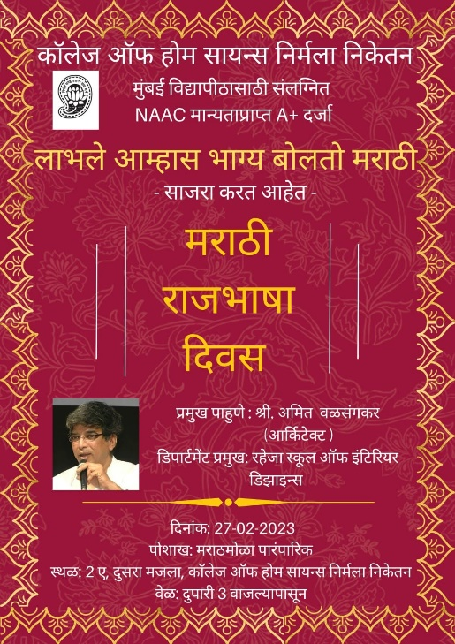
The program commenced with our compere Mrs. Vibhuti Khedekar the host of the program and Convenor of Marathi Bhasha Divas committee, who began by welcoming all the dignitaries, guests, faculty members, and students. The chief guest for the program was Mr. Amit Valsangkar, Head of the Department B.Voc (Interior Design) L.S. Raheja School of Architecture.

Dr. Anuradha Bakshi, In-charge Principal delivered the welcome address. Ms. Cheryl Machado, Member of the Nirmala Niketan Institute Management also gave her best wishes to all for the program.

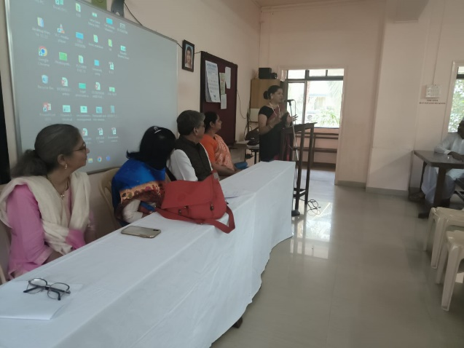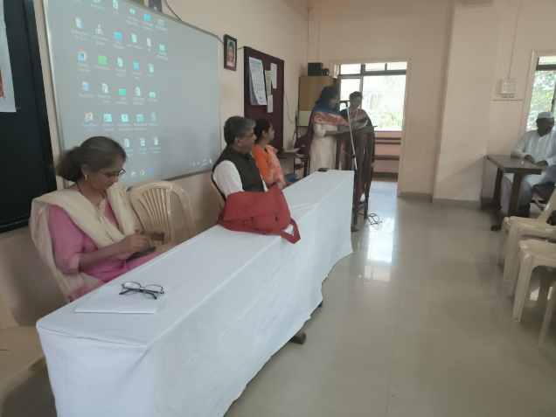
Any program is incomplete without the active participation of our students. Students of F.Y.B.Sc, S.Y.B.Sc, and T.Y.B.Sc (both Maharashtrian and Non-Maharashtrian) enthusiastically performed various songs, and dances. They narrated beautiful poems, and speeches.
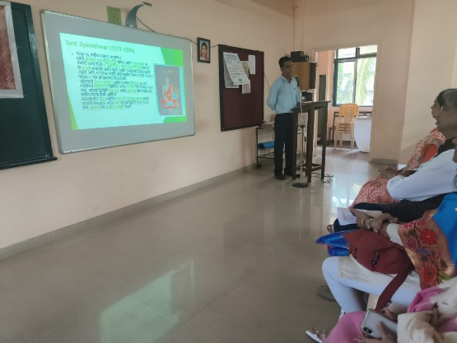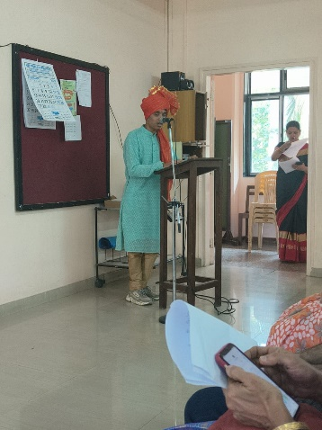
Ms. Shravani Jadhav- FYBSC recited a beautiful prayer, Ms. Apeksha Pawar- T.Y.FND performed a sit-down choreography on a Marathi Song, Ms. Manasi Palande- T.Y.HD danced on a beautiful song “Swamini”, Mr. Atharva Sanas- F.Y.GDVC recited a beautiful poem.
Ms. Maitreyee Kulkarni- FYJC recited a poem from a poetry book written by her mother. Ms. Muskaan Sayeed- T.Y.HD narrated her story of how Marathi language has made a positive impact on her life. Students from the Department of Textile and Fashion performed on a famous folk art- “Powada”
Mr. Amol Surt, staff from the Junior College recited the Abhyangas of Sant Tukaram and Sant Dyaneshwar. Mrs. Prajakta Mhaprolkar, librariran beautifully depicted the work of V.D Sawarkar. She mentioned that 26th February 2023 marks the 57th Death Anniversary of Veer Damodar Savarkar, who is widely considered the father of Hindu nationalism.
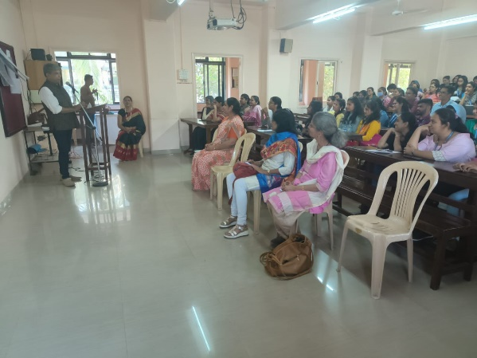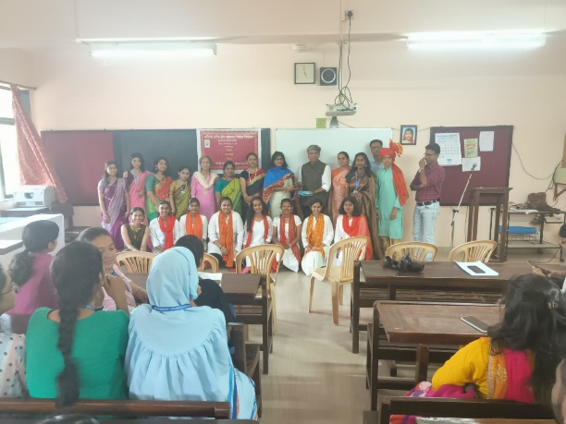

We were honored and delighted to welcome Mr. Amit Valsangkar the chief guest for the program who is versatile and has deep knowledge about the Maharashtrian culture and heritage. He explained how powerful the Marathi language is. He quoted many examples of the renowned literature of great personalities right from Chhatrapati Shivaji Maharaj, to Sant Tukaram and Sant Dyaneshwar to Swatantra veer Swatantra veer and many more. He also recited a few lines written by Kavi Kusumagraj.
Mr. Amit being an Architect by profession spoke profoundly about the forts of Maharashtra and its history and importance.
Overall it was a wonderful program where the commemoration of the Marathi Raj Bahsha Divas happened in the true sense of the term. The Program concluded with a vote of thanks from Mrs. Vibhuti Khedekar.
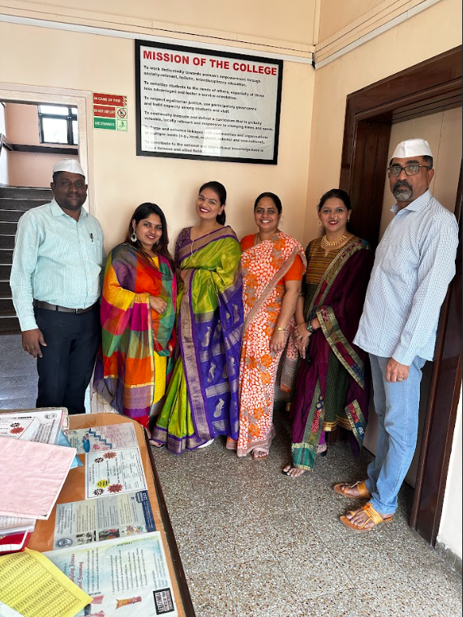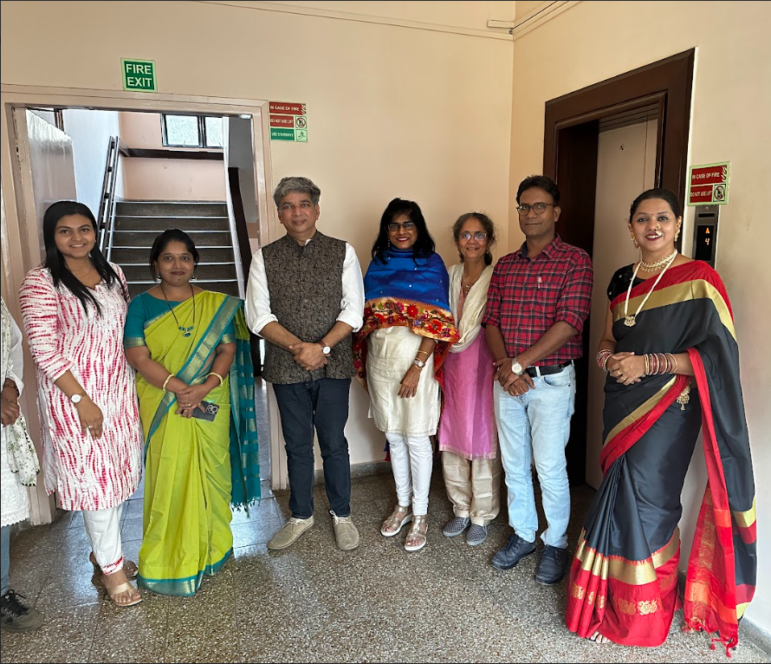
The staff and students enthusiastically dressed up in traditional Maharashtrian attire to commemorate and actively participated in the program. The guests and the dignitaries relished the special Maharashtrian refreshments. 75 students and 15 staff attended the program.

Mrs. Vibhuti Khedekar
Convenor
Marathi Bhasha Divas Committee
2022-2023

