COLLEGE OF HOME SCIENCE NIRMALA NIKETAN
REPORT ON INTERFAITH COMMITTEE 2022-2023
The Interfaith Committee consists of the following members
Sr. No | Name of the Staff
1 | Mrs. Vibhuti Khedekar | Convenor
2 | Ms. Rhonda Divecha | Member
3 | Dr. Anjali Srivastava | Member
4 | Mrs. Sheetal Fernandes (Junior College) | Member
5 | Mrs. Aashiyaan Amrelia (Self Finance Courses) | Member

The elections for the Interfaith Committee student volunteers were held on 12th October 2022, 09 student representatives from all levels were present for the meeting. The students elected their leaders by voting for them.
Following students were elected to be the student leaders of the Interfaith Committee 2022-2023
Sr. No | Name of the Student | Class of the student | Post | No of Votes received
1 | Riya Gandhi | TYHD | Student Convenor | 09 votes
2 | Palak Shah | TYFND | Secretary | 09 votes
3 | Mansi Palande | TYHD | Treasurer | 07 votes

RAKSHA BANDHAN
RAKHI FOR RAKSHAK A SALUTE TO OUR ARMED FORCES
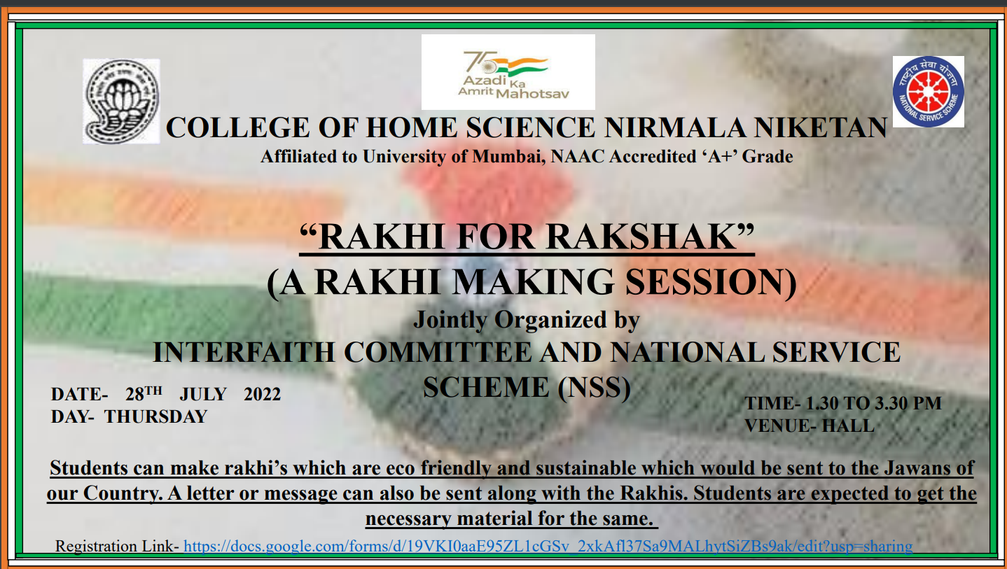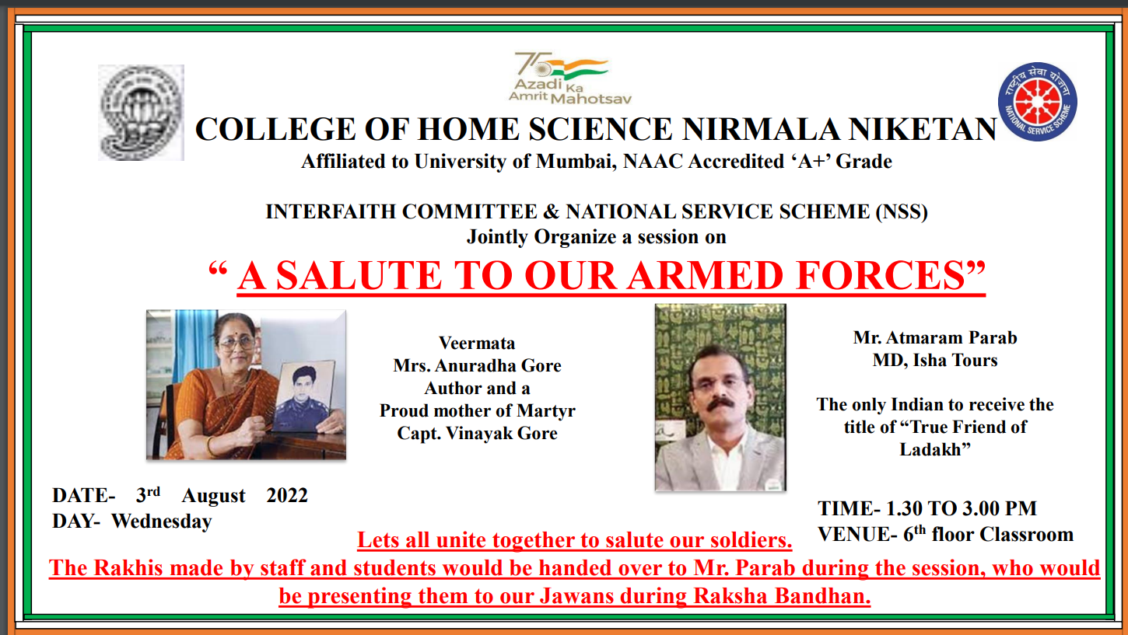
The Interfaith committee and National Service Scheme (NSS) of College of Home Science Nirmala Niketan jointly organized two sessions on
- Rakhi for Rakshak (A Rakhi making Session) on 28th July 2022
- A Salute to our armed forces on 3rd August 2022

More than 200 students enthusiastically made handmade Rakhi’s along with a personalized message for the jawans.
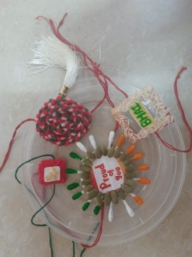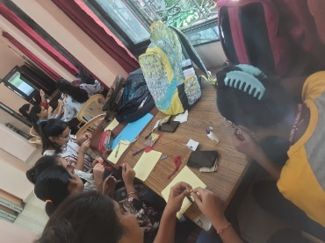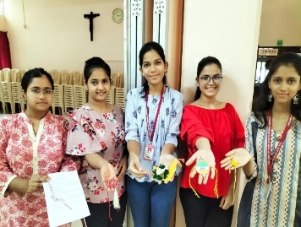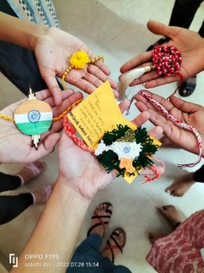
Rakhi Making session

On 3rd August 2022 a session on “A Salute to our armed Forces” was conducted where the rakhis made by our staff and students were handed over to Mr. Atmaram Parab, MD Isha Tours who presented them to Mi Ladakh Scout Regiment, Ladakh during the Raksha Bandhan Festival.
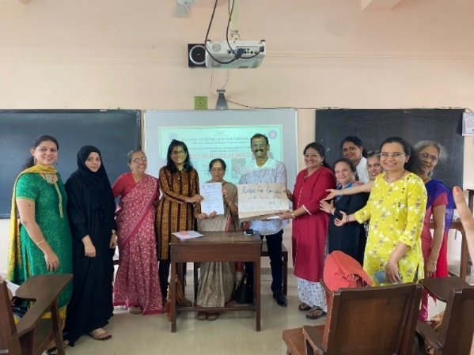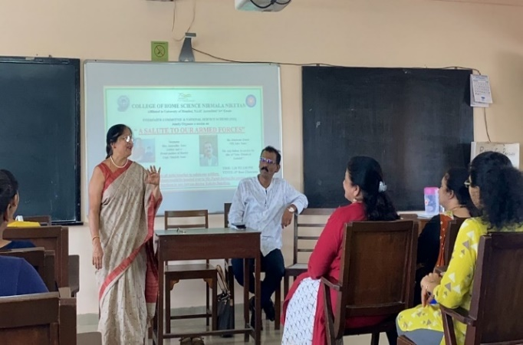
Handing over the Rakhis to Veermata Mrs.Anuradha Gore
Mr. Atmaram Parab, MD Isha Tours Mother of Martyr Capt. Vinayak Gore

On the same day, Veermata Mrs.Anuradha Gore was invited as a special guest. She is a renowned author and is a proud mother of Mother of Martyr Capt. Vinayak Gore. Mrs. Anuradha Gore, a teacher by profession, is a heroic mother who in her pursuit to keep the promise given to her late son Captain Vinayak Gore, has played the motherly role in the real sense to hundreds of Vinayaks by inspiring them to join the army. She during her speech shared some overwhelming experiences that her son and the Indian armed forces experienced while serving the nation. She has written columns in newspapers on the same. She has authored eight books in Marathi, most of them about soldiers, and is presently penning what could be the first book in this language on Siachen and what it takes to guard it. She has inspired a large number of young men and women in Maharashtra to join the Army. While talking to the students she narrated various experiences of her own too which she has experienced after the death of her son. Some of the books written by her are Shaurya, Kathasagar, Ranasangram etc. We were very proud and happy to interact with her. She left everyone teary-eyed.

Raksha Bandhan at Ladakh Scout Regiment
It was a moment of joy and pride for all at College of Home Science Nirmala Niketan, when the rakhis made by our staff and students were presented by Mr. Atmaram Parab to all the soldiers of Ladakh Scout Regiment in Leh-Ladakh on RakshaBandhan
All the soldiers liked the greetings and rakhis made by our students. They were very happy ( Message from Atmaram Parab Sir)
He has also beautifully penned down the entire experience in his Facebook post.
Following is the link https://m.facebook.com/story.php?story_fbid=pfbid02ZXpTt249G3pL3HxzLBZx1TCRvq9gpAUL2uW2eQuRYyi4BeJ7KMjhEjfGjKRW1qmwl&id=721840492
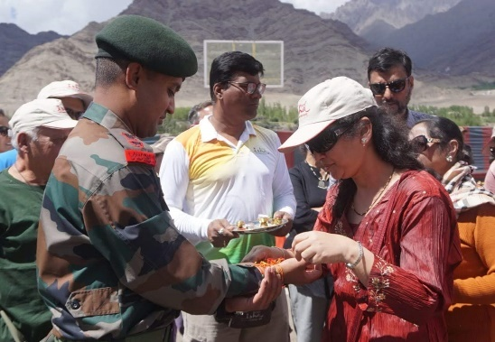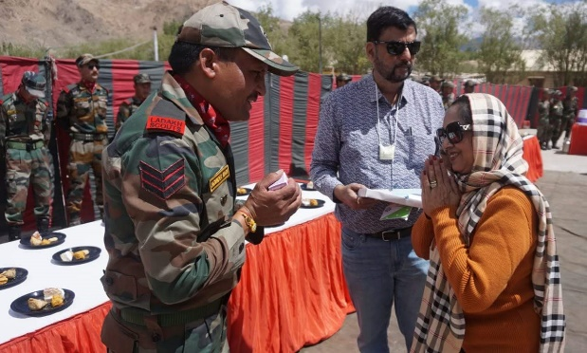
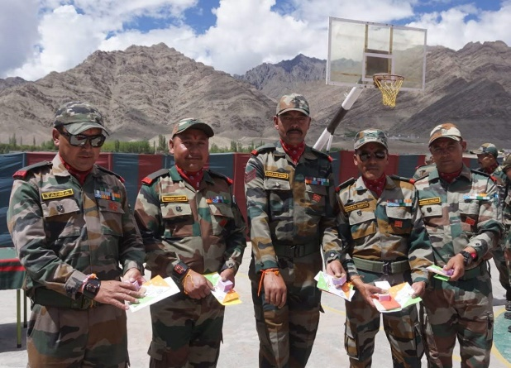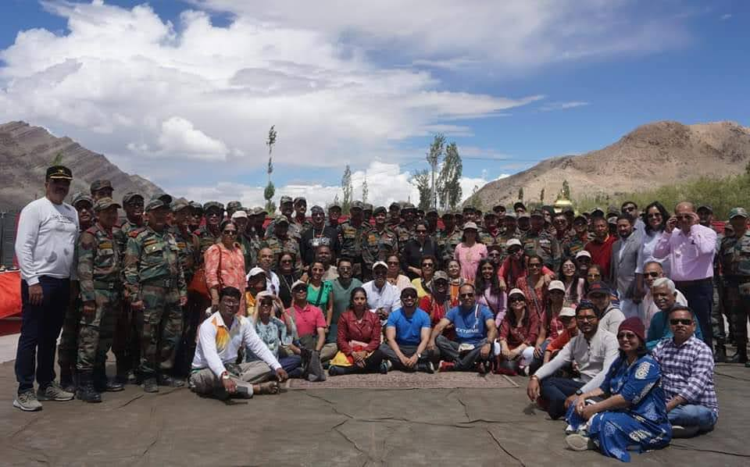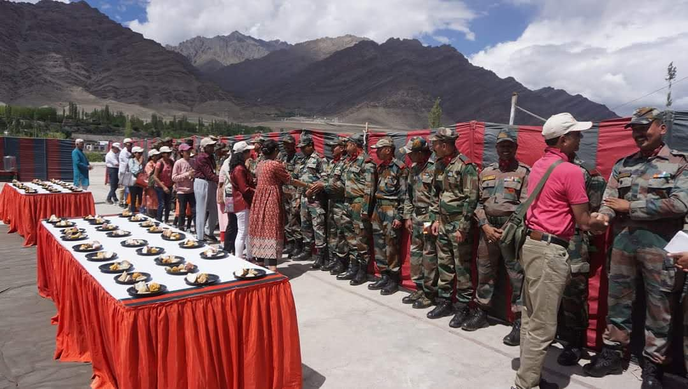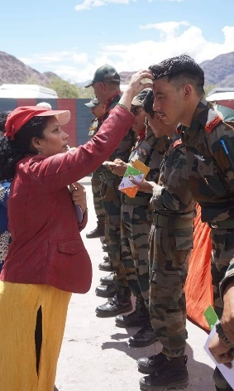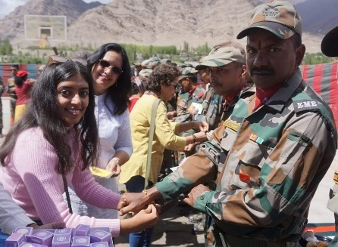
Raksha Bandhan at Ladakh Scout Regiment

DANDIYA
The Interfaith committee and Cultural committee in collaboration with IQAC organized 2 Dandiya namely Dandiya and Dandiya 2.0 on 29th September 2022 and 1st October 2022 respectively celebrate the festival of Navratri. DJ Tejas was invited for the same and it was a grand celebration with more than 500 students (250 per day) participating on each of the days
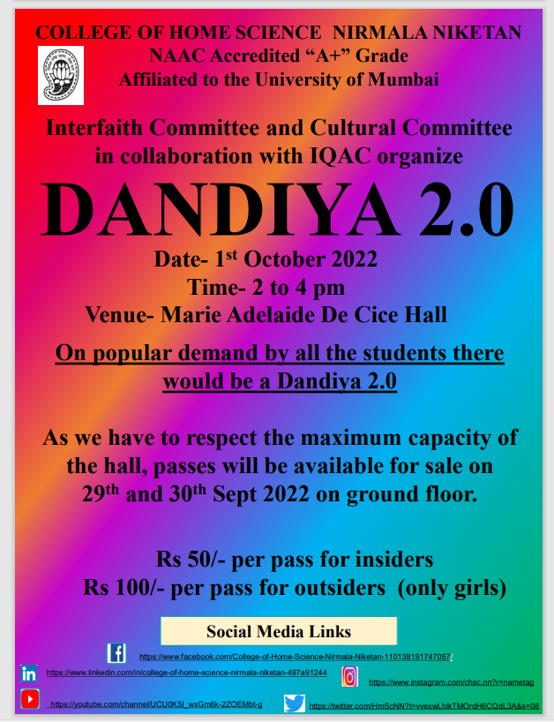

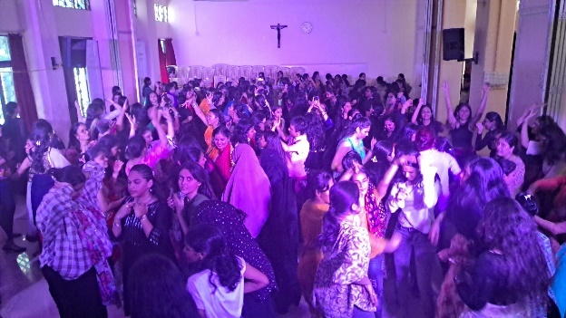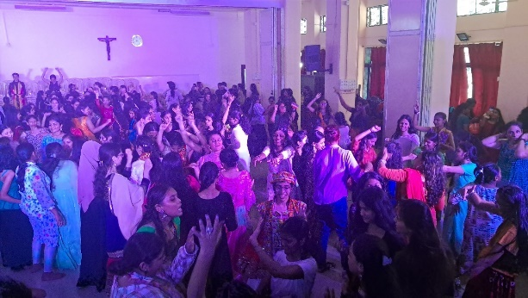
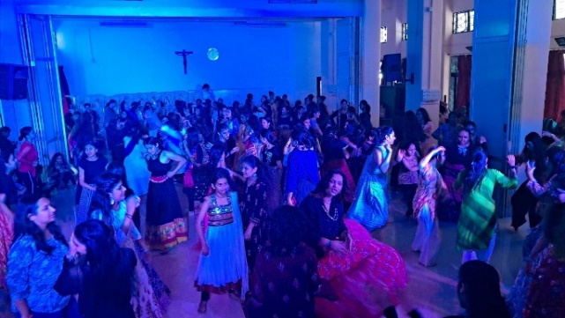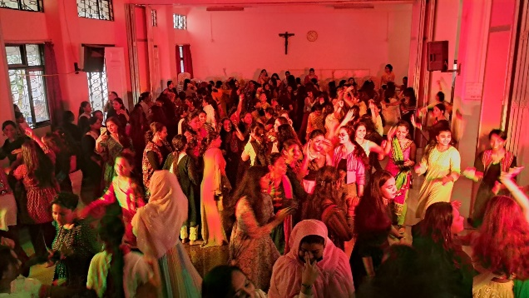
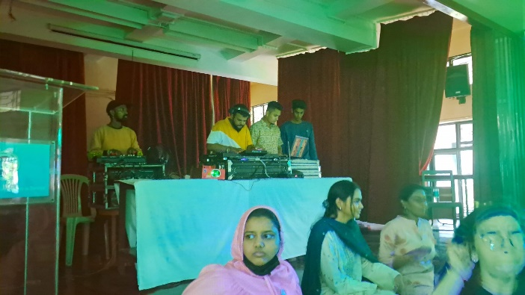

KHADI UTSAV
INTER COLLEGIATE COMPETITION ON INNOVATIVE PRODUCT DEVELOPMENT
The College of Home Science Nirmala Niketan in Collaboration with IQAC and the Institution’s Innovation Council organized “Khadi Utsav” an Intercollegiate competition on Innovation Product Development using Khadi fabric, to commemorate Gandhi Jayanti.
Khadi is a traditional fabric of India which is also known as the freedom fabric. Khadi fabric was associated with the freedom struggle and Swadeshi Movement. With the advent of synthetic fabrics the use of Khadi fabric decreased. Over a period of time Khadi seemed to lose its value among the consumers. The young generation today is not completely aware about the importance of this traditional fabric and the ideology behind it.
The purpose of conducting this competition was to create awareness about the Khadi fabric and also help students create innovative products which can show the diversity of the Khadi fabric.
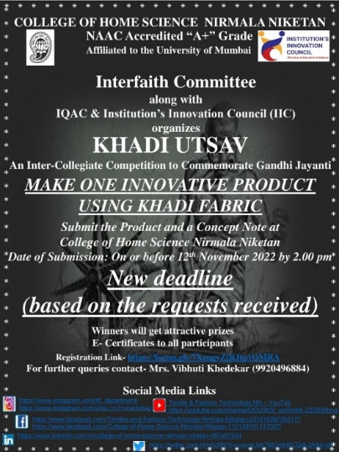
A total of 9 participants registered for the competition but only 7 participants from various colleges in Mumbai sent their innovative products made out of Khadi fabric.
The participants made innovative products out of the Khadi fabric Students submitted a range of products eg- Garments, accessories, jewellery, stationary products, and home décor products etc. A concept note was submitted with each of the product explaining the details of the product.
The judge of the competition was Dr. Ela Dedhia who has a vast experience in the field of Khadi.
Details of the Participants and Winners
SR NO | NAME OF THE STUDENT | NAME OF THE COLLEGE | PRIZE
1 | Miss Charisma Thampy | College of Home Science Nirmala Niketan | 1ST Prize
2 | Miss. Janice Devassy | College of Home Science Nirmala Niketan | 2nd Prize
3 | Miss. Fatema Mahuwala | College of Home Science Nirmala Niketan | 3rd Prize
4 | Miss. Afifa Shaikh | SVT College of Home Science | 3rd Prize
5 | Miss Kamil Afifa Mohd. Hamid | Dr. BMN College of Home Science | Consolation
6 | Miss. Akshata Kharat | Laxmi Chand Golwala College of Commerce and Economics
7 | Miss. Vishaka Wankhade | Laxmi Chand Golwala College of Commerce and Economics

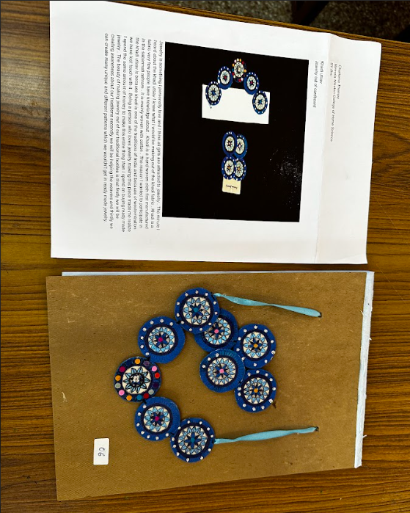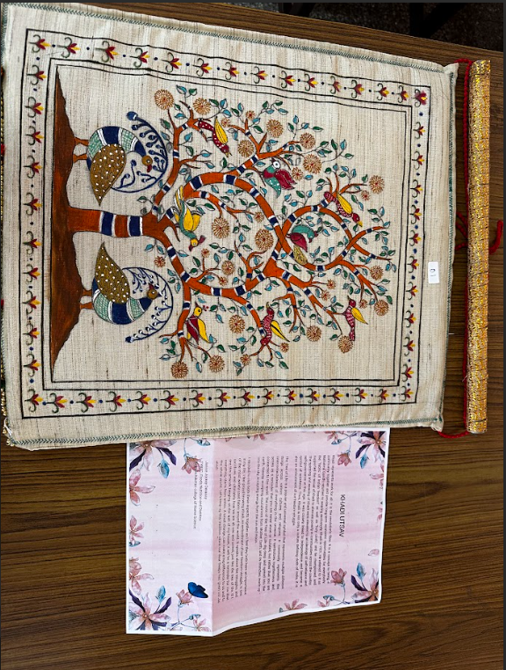
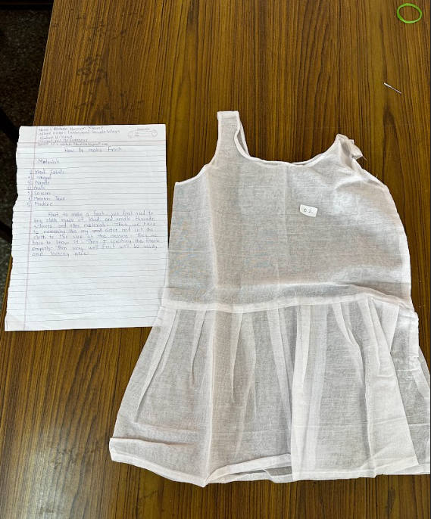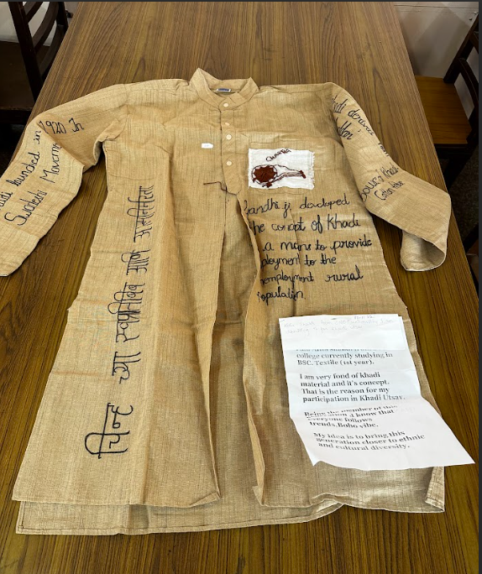
\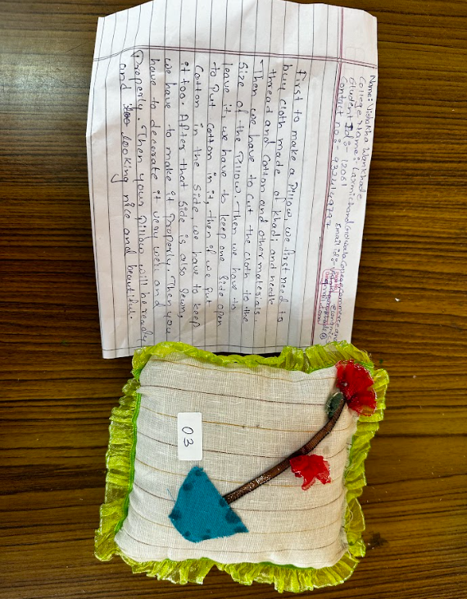 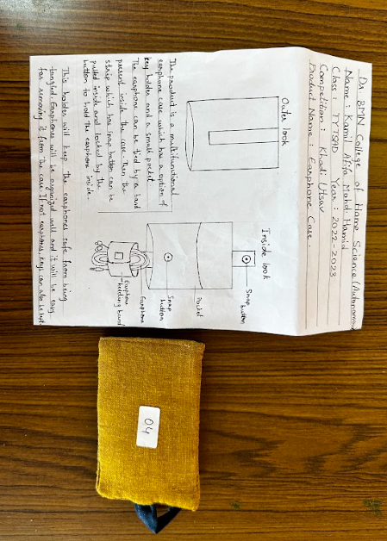

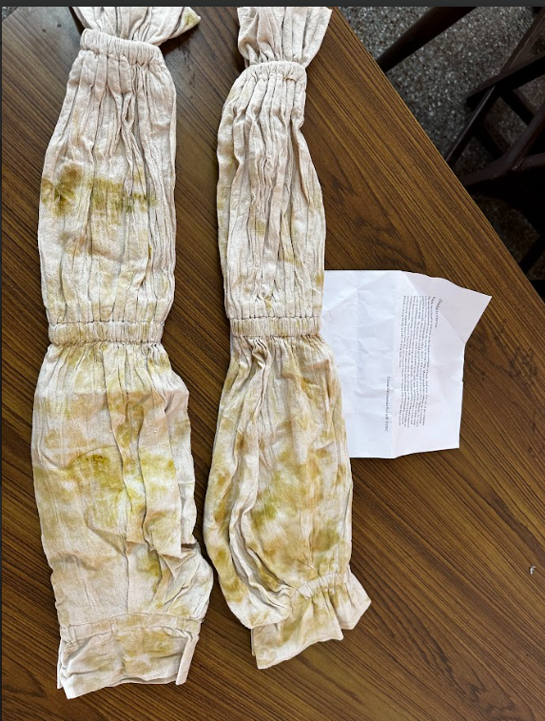
Innovative Khadi Products developed by students
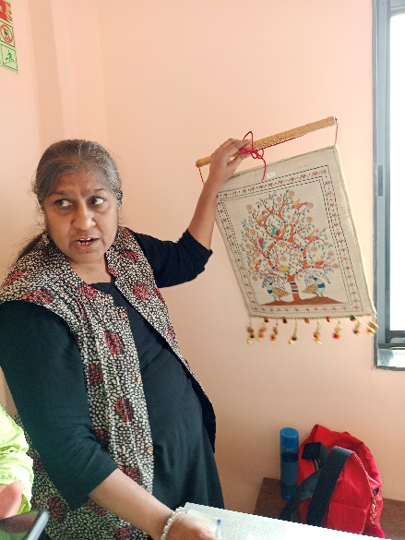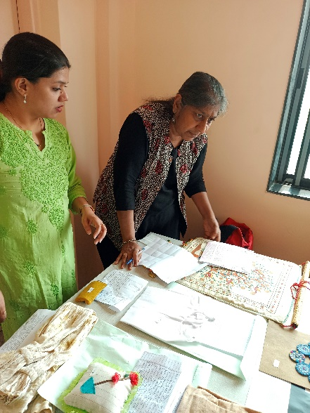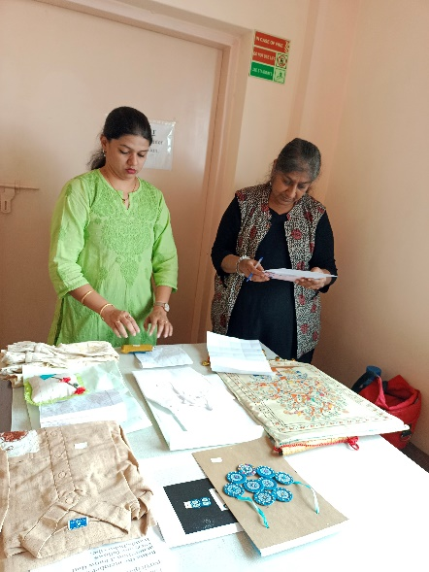
Judge- Dr. Ela Dedhia
Former Head of the Department Textile and Fashion Technology,
College of Home Science Nirmala Niketan
Certificates

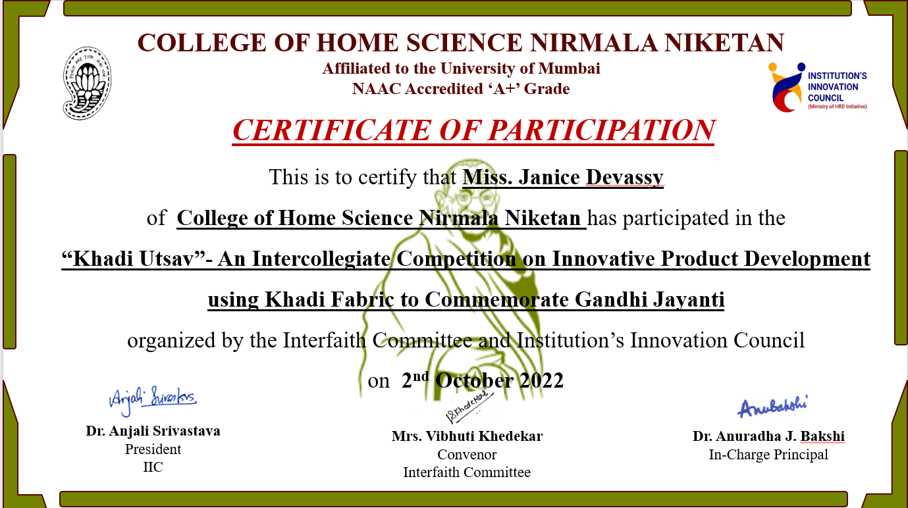

CAROL SINGING INTERCOLLEGIATE COMPETITION
The College of Home Science Nirmala Niketan organized a Carol singing competition. This event was organized by the Cultural Committee and Interfaith Committee. The competition was held on the 22nd of December, 2022.
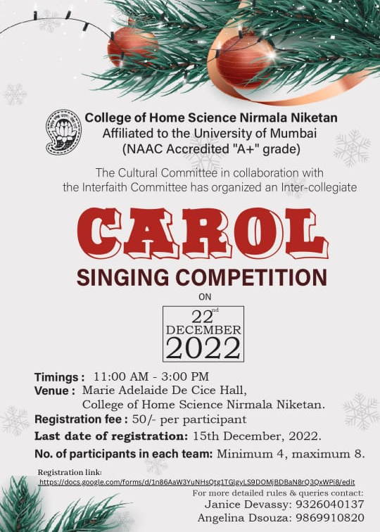
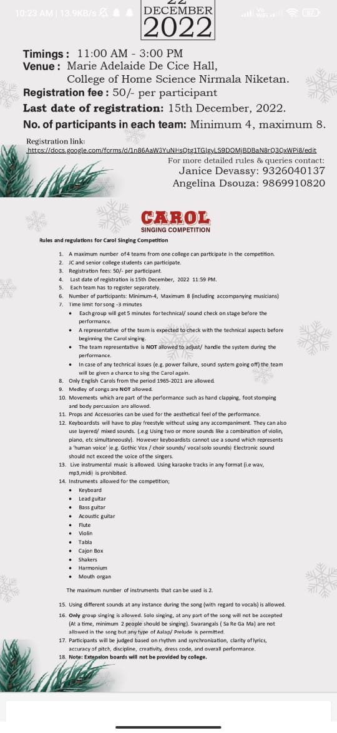
Names of colleges that participated in the competition:
- Wilson college (2 teams)
- Xavier’s college (1 team)
- College of social work Nirmala Niketan (3 teams)
- College of Home Science Nirmala Niketan (3 yeams)
The competition began at 11.00 am in the Marie Adelaide De Cece hall. All participants registered themselves and did the sound and technical checks. Our I/C principal, Anuradha Bakshi gave a warm welcome to the Participants and audience in the hall. The judges were introduced by the convenor of the cultural committee: Ms. Payal Maheshwari.
The judges for the event were:
- Fr. Frinto
- Ms. Mylene Sequeira

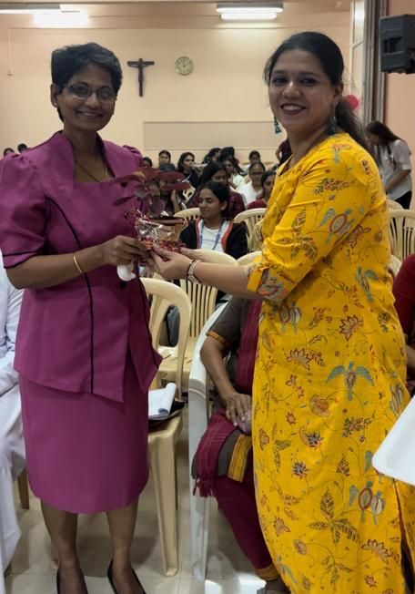
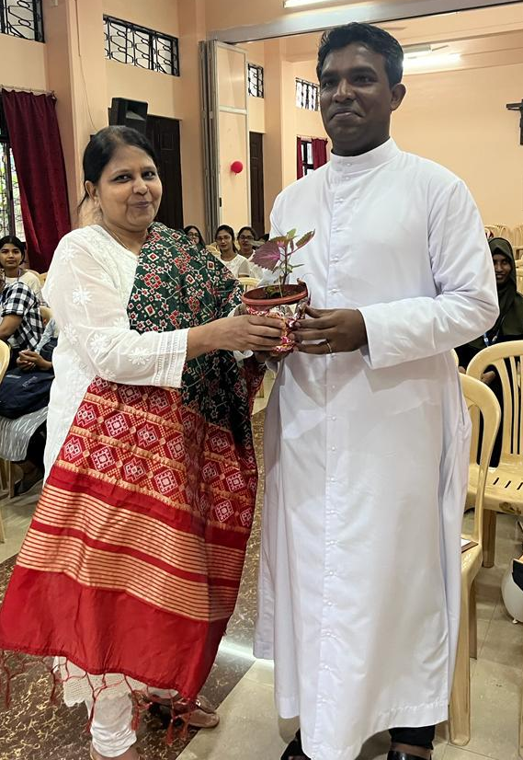

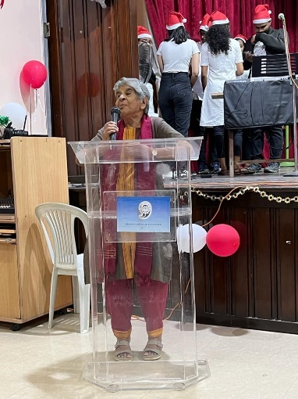

All teams put up an excellent performance. Everyone in the hall was mesmerized with the lovely tunes of the carols and the Christmas spirit brightened! The winners of the competition were:
- College of Home Science Nirmala Niketan- 1st Prize
- College of Home Science Nirmala Niketan- 2nd Prize
- Wilson college- 3rd Prize
Ms. Rhonda played for the crowd a lovely song. The winners were felicitated with certificates. The event ended with a vote of thanks by Ms. Vibhuti Khedekar.
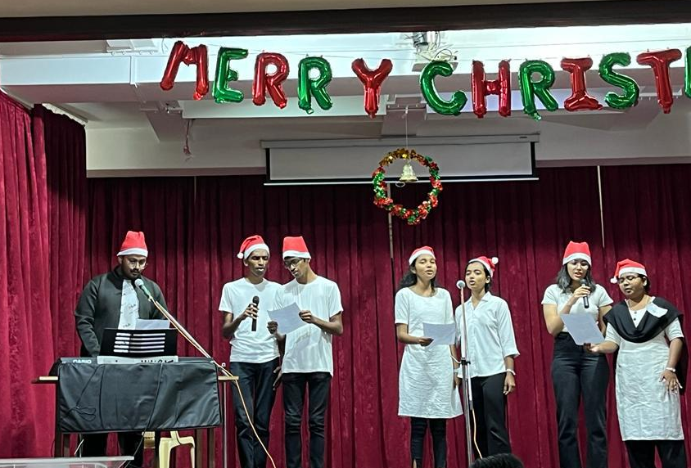
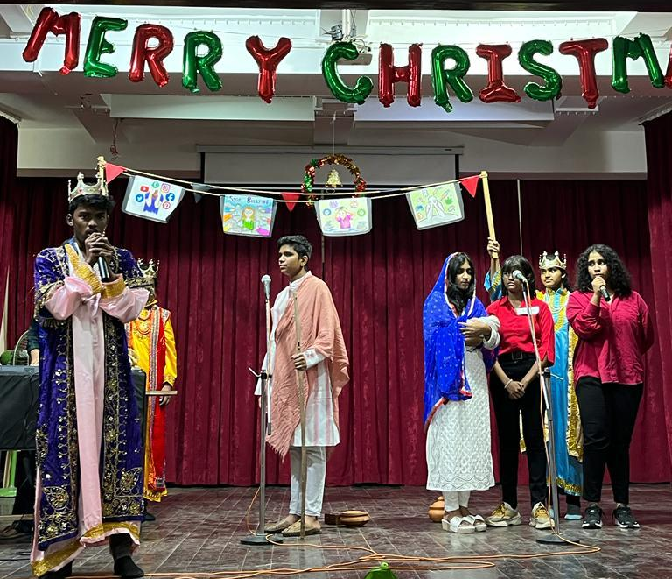

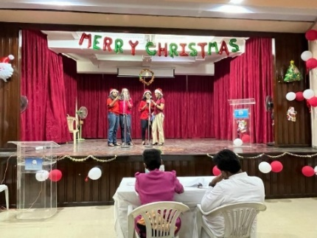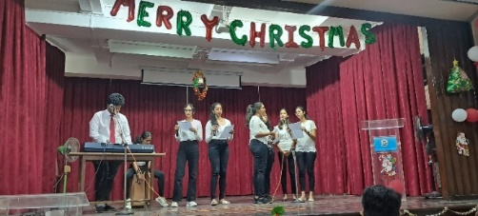

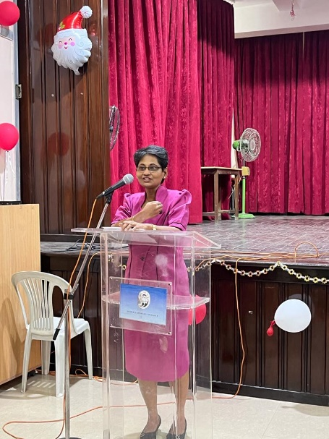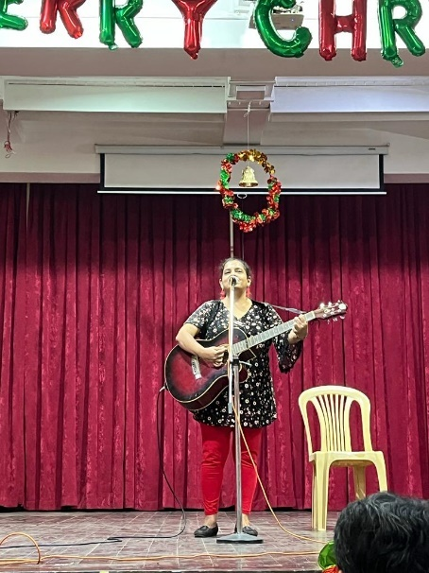

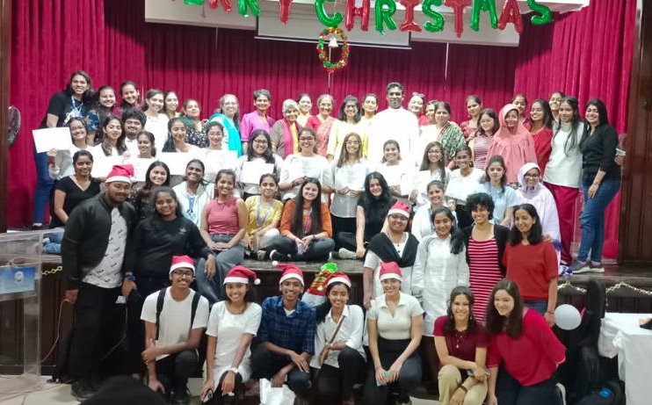
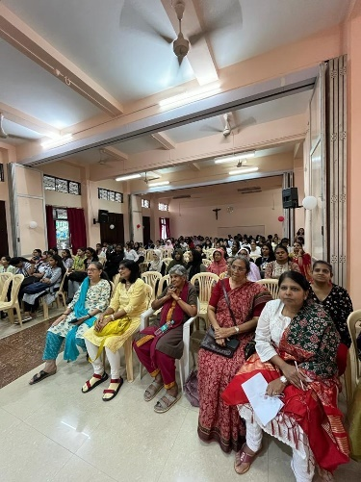

List of participants for Carol Singing Competition
1.Name of college: Wilson College
SR. NO | Name of the student | Department | Contact number
 | Sumra Mohammed | SYJC- ARTS
 | Sebasteen Anthony | SYJC-ARTS
 | Gisftson Jayapaul | FYJC-ARTS
 | Naomi Willis | FYJC-ARTS
 | Angelina Michael | FYJC-ARTS
 | Aishwarya Amit | FYJC-ARTS
 | Shamuvel Mhaske | SYJC-ARTS
 | Linette Fraizer | FYJC-ARTS

2.Name of college: Wilson college
SR. NO | Name of the student | Department | Contact number
1. | Crizelda Menezes | SYBA
2. | Priyanka Jagtap | SYBA
3. | Jemima Kunder | SYBA
4. | Leah Tauro | SYBA
5. | Nelisma Soreng | SYBA
6. | Aditi Dubey | SYBA
7. | Jadzia das | SYBA

3.Name of participants: St. Xaviers Institute of Education
SR. NO | Name of the student | Department | Contact number
1 | Nicole Gonsalves | SY- BED | 9930836015
2. | Elsinda Nunes | SY-BED | 8097818832
3. | Rachel Thevar | SY-BED | 9833806164
4. | Delviya Misquitta | SY-BED | 9075452151
5. | Rhea Gonsalves | SY-BED | 8698355020
6. | Myron Gomes | SY-BED | 9833371058
7. | Sanica Coutinho | SY-BED | 7507387262
8. | Leeandra Pinto | SY-BED | 9167640827

4.Name of participants; College of Home Science Nirmala Niketan
SR. NO | Name of the student | Department | Contact number
1. | Zara Furtado | FYJC
2. | Megan Braganza | FYJC
3. | Eva Almeida | FYJC
4. | Kyraa Lobo | FYJC
5. | Adriaana vaz | FYJC

5.Name of participants; College of Home Science Nirmala Niketan
SR. NO | Name of the student | Department | Contact number
1. | Kiara Noronha | SY Bsc
2. | Angelina dsouza | SY Bsc
3. | Natlyn D’mello | SY Bsc
4. | Megan Monteirro | SY Bsc

6. Name of participants: College of Home Science Nirmala Niketan
SR. NO | Name of the student | Department | Contact number
1. | Jerusha Cabral | MSC-1 HD
2. | Lydia Samuel | MSC-1 HD
3. | Abigail Fernandes | MSC-1 HD
4. | Bhairavi Naik | MSC-1 HD

7. Name of participants: College of Social Work Nirmala Niketan
SR. NO | Name of the student | Department | Contact number
1. | Priti |  | 8779564274
2. | Lorina |  | 9082129047
3 | Biviyana
4 | Nelita gonsalves
5 | Simran alvares

8. Name of participants: College of Social Work Nirmala Niketan
Sr. No | Name of the student | Department | Contact number
1 | Prerna
2 | Aishwarya
3 | Treesa
4 | Divya
5 | Alen
6 | Myron
7 | Merwyn

9. Name of participants: College of Social Work Nirmala Niketan
Sr. No | Name of the student | Department | Contact number
1 | Sanjeevan
2 | Sundar
3 | Sara periera
4 | Mahima
5 | Adriel josna
6 | Aneesha
7 | Sara feriera

DIWALI CELEBRATION
The students of the Interfaith Committee had a pre-Diwali celebration where they decorated the college reception are with a beautiful Rangoli and diyas. The staff of the college also celebrated by lighting the diyas
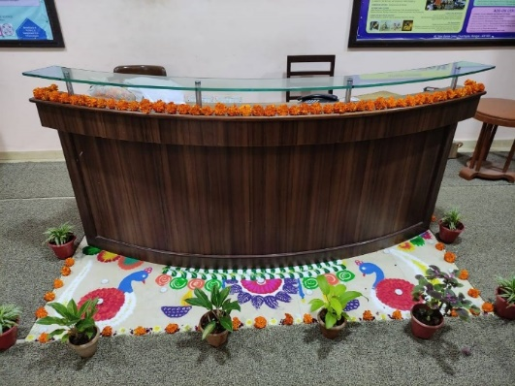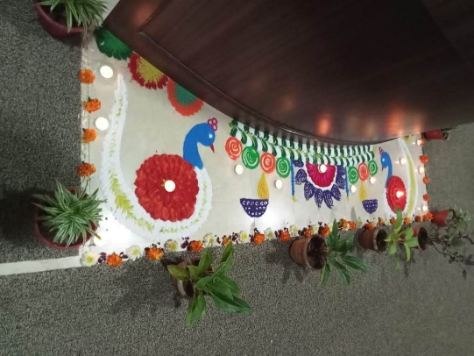
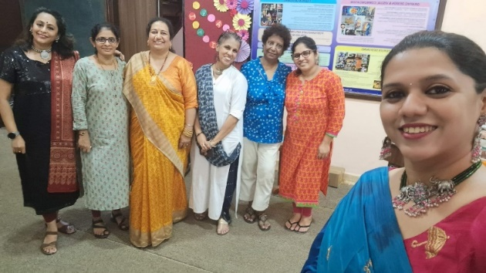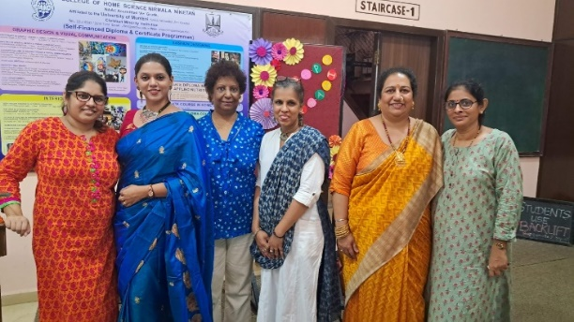
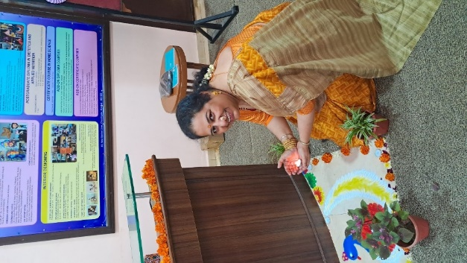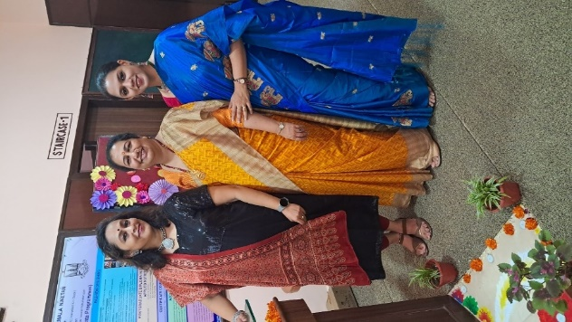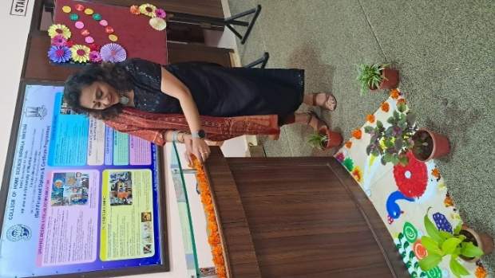

CHRISTMAS CELEBRATION
Christmas is a very special festival celebrated at the College of Home Science Nirmala Niketan.
The Interfaith committee of the College of Home Science Nirmala Niketan organized the Christmas program to celebrate the festival of Christmas.

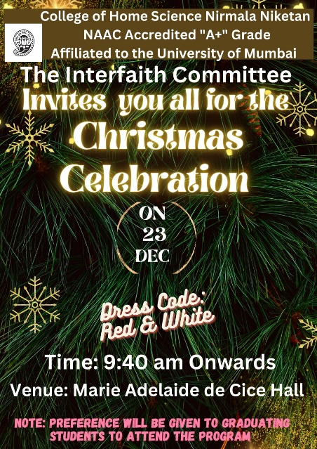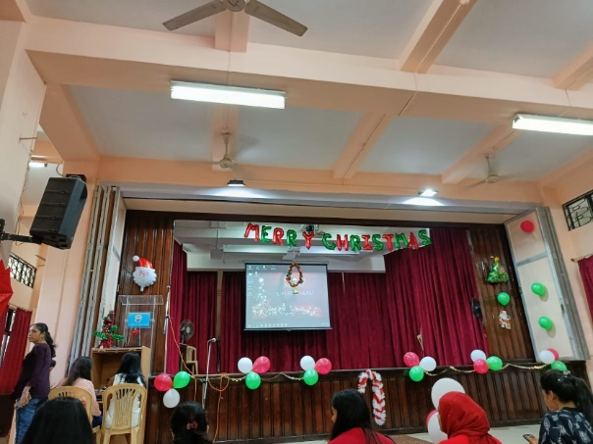
The Interfaith committee members beautifully decorated the reception area with the theme of Christmas.

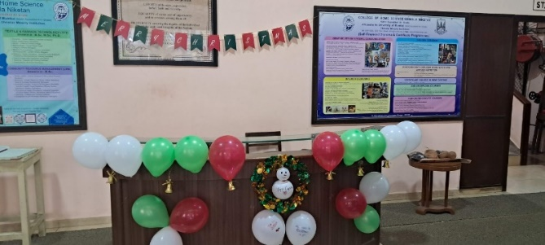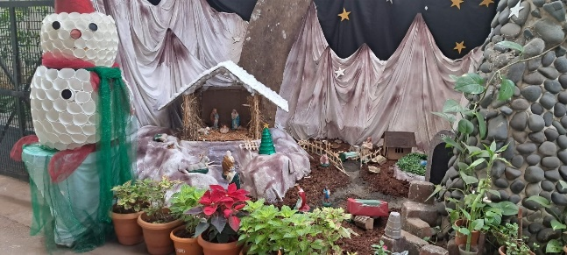
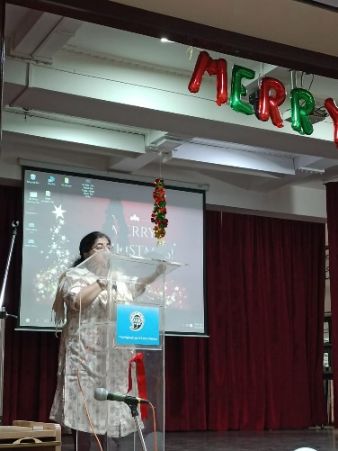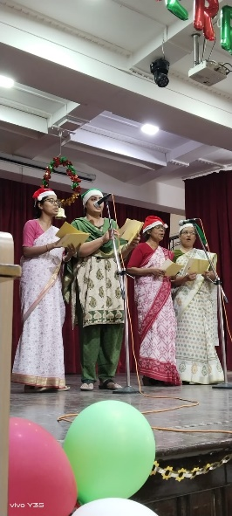
Dr. Vishaka Karnad Members of the DHM Management
Delivering a Christmas message Carol Singing

Students from junior college, degree college and self-finance courses actively participated in the celebration.
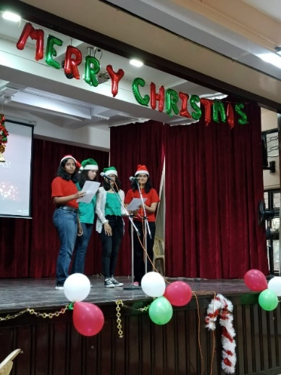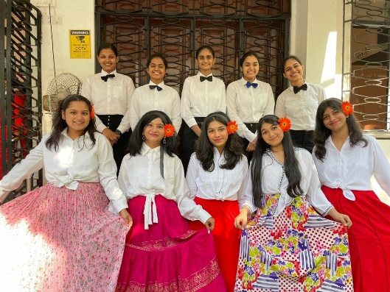

The students of Junior College performed Carols and also danced to traditional Goan songs.
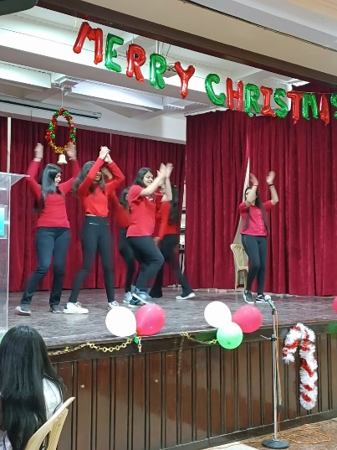

Degree college students and Self-finance courses students also performed carols, skits, and dances. Ms. Erum Shaikh from F.YBSC performed Carol Singing, Ms. Imam Shaikh from F.YBSC sang a melodious song. The students from M.Sc I performed on a melody of carols.
The student convenor of the interfaith committee Ms. Riya Gandhi from T.YHD and her team performed 2 dances. The treasurer of the Interfaith committee Ms. Mansi Palande T.YHD and her teammates performed a heart-touching skit. Ms Melan Peraria from S.Y.BSc and her team performed their carol melody which they won in the Intercollegiate Carol singing competition. A special surprise was planned for all where a Santa clause distributed chocolates to all Mrs. Vibhuti Khedekar delivered the vote of thanks
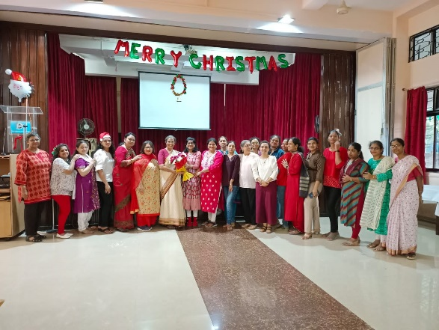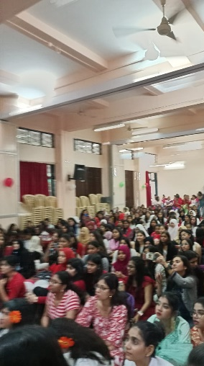
The audience thoroughly enjoyed the program.

Mrs. Vibhuti Khedekar
Convenor
Interfaith Committee
2022-2023

