REPORT ON NATURE CLUB ACTIVITIES HELD IN 2022-2023
The Team of Nature Club consists of the following teachers
Mrs. Vibhuti Khedekar- Convener
Dr. Neha Mulchandani- Member
Ms. Shalmalee Potdar- Member (on leave vacancy of Ms. Fatima Kader- Member)
Mrs. Blossom Alvares- Member
FLAMINGO WATCHING CUM NATURE TRAIL

The Nature Club of College of Home Science Nirmala Niketan organised a Flamingo Watching activity at Thane Creek on the 29th January 2023 in collaboration with The Tern Travellers.5 students and 2 staff members participated in the activity.
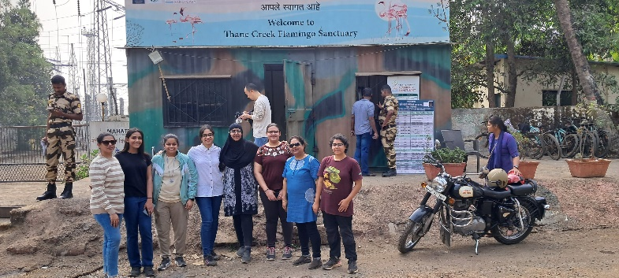
The participants reached the location at 7.30 am and began with the nature trail along with the tour manager Ms. Vidushi Jaiswal from The Tern Travellers. She during the nature trail oriented the students about Flamingos. She mentioned that Flamingos are resident to India as well as winter visitors. They migrate from states such as Gujarat and Rajasthan, as well as from Iran, Afghanistan, Pakistan, and even Israel. The flamingos’ arrival and departure are dependent on the movement of the monsoon.
Ms. Vidushi gave detailed information about the different types of birds in and around the Thane Creek.She also explained about the different types of trees plants and their importance.
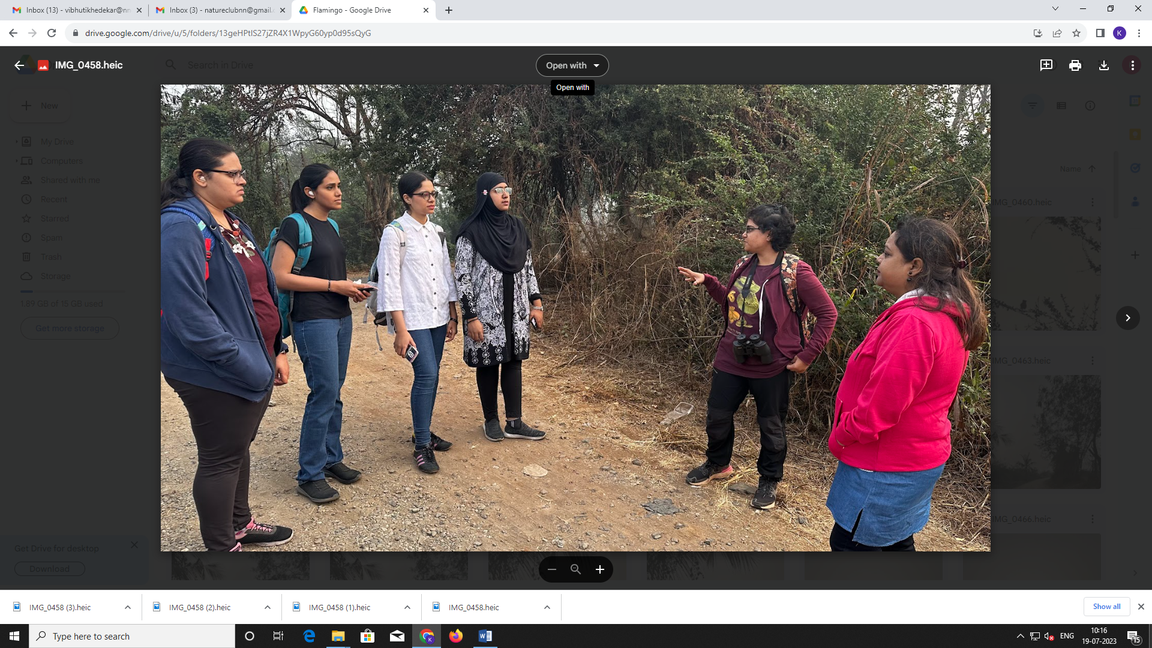
Ms. Vidushi also explained the importance of the Thane Creek which is is truly one of the best kept secrets for observing birds. To explore the creek the participants took a boat ride where they observed a large number of Lesser and Greater Flamingos along with various other birds such as Avocets, Northern Shoveler, Grey Heron, Egrets, Plover, Sandpiper, Black headed Ibis, Whimbrel etc to name a few.

Overall it was a joyous experience for all and all the participants enjoyed the Flamingo Watching cum nature train experience.

TREK TO RAIRESHWAR: NATURE TRAIL CUM TREK
The Nature Club of College of Home Science Nirmala Niketan in collaboration with Trekophy, organized the much-awaited and tremendously in-demand Nature Trail cum trek of the year on 4th and 5th February 2023, to Raireshwar, Bhor, Pune. In all 50 students and 4 staff participated in the trek.
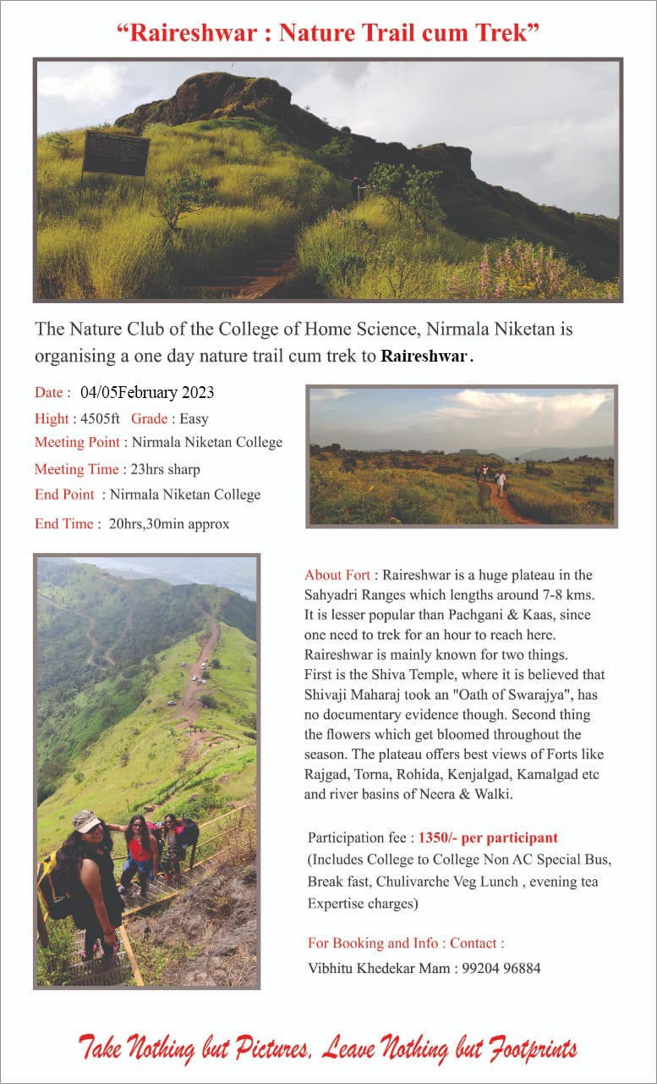
Raireshwar is situated in Bhor Taluka near Pune, India. Raireshwar has a temple famous for its historical importance. The temple is very old and of stone structure, but it was later re-constructed in 18th century. It is situated in between various hills and forts such as Kenjalgad. The temple is on a plateau, which is full of beautiful flowers during monsoon.

Chhatrapati Shivaji Maharaj took the oath of Hindavi Swarajya in this temple at the age of 16 in 1645 and then created history. Its said that he had cut his little finger and taken the oath by dripping blood onto the Shivling. There is a large portrait of Shivaji Maharaj and his friends inside the temple. Thus, Raireshwar can be considered as an important place in Maratha history.
The trek began where Mr.Amol Joshi from Trekophy briefed students about Raireshwar and the details of the trek. A lot of detailed information was also given to students regarding the importance of soils found on the plateau of the fort.
A home made meal was arranged for the students during the lunch time in the village situated on the fort.
It was an enriching experience and a superb get away from the concrete jungle. Students’ enjoyed the beautiful nature. Every student enjoyed a lot and were back safe and sound with sweet memories.
Mrs. Vibhuti Khedekar
Convenor
Nature Club
2022-2023

